LESSON PLAN
NUMERATION – COUNTING - TABLE
Gcompris

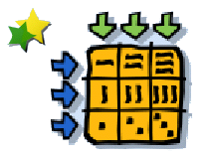
CLICK:

GOALS:
- To develop counting skills
- To get familiar with table (lines and column)

CONTEXTUALIZATION: To work with table.

HOW TO PLAY: Drag and drop each proposed item on its destination in the table.
