***Help your students improve their English-language skills by creating their own language dictionary.***

**Record/Write: Language Development**

C:\Documents and Settings\Julia\Local Settings\Temporary Internet Files\Content.Word\Screenshot_1_2_3_4.pngC:\Documents and Settings\Julia\Local Settings\Temporary Internet Files\Content.Word\Screenshot_1_2_3_4.png

How:

Ask your students to take a picture of various objects in the school-yard or in the classroom. Have them put these pictures on the ‘clipboard’ and drag them into Write C:\Documents and Settings\Julia\Local Settings\Temporary Internet Files\Content.Word\Screenshot_1_2_3_4.png. Under each picture, they write the name of the object in Kinyarwanda and also in English.

**2.** Now have your students search their classroom and school-yard for objects to take pictures of. As they take pictures, you will see the pictures show up on the bottom of the screen. Once your student has taken their pictures, they must ‘copy to clipboard’ to bring their photos into WriteC:\Documents and Settings\Julia\Local Settings\Temporary Internet Files\Content.Word\Screenshot_1_2_3_4.pngYou do that by just moving your mouse on top of the picture(s) you want to work with. Once your mouse is over the photo you should see the menu below. Just click on ‘copy to clipboard’

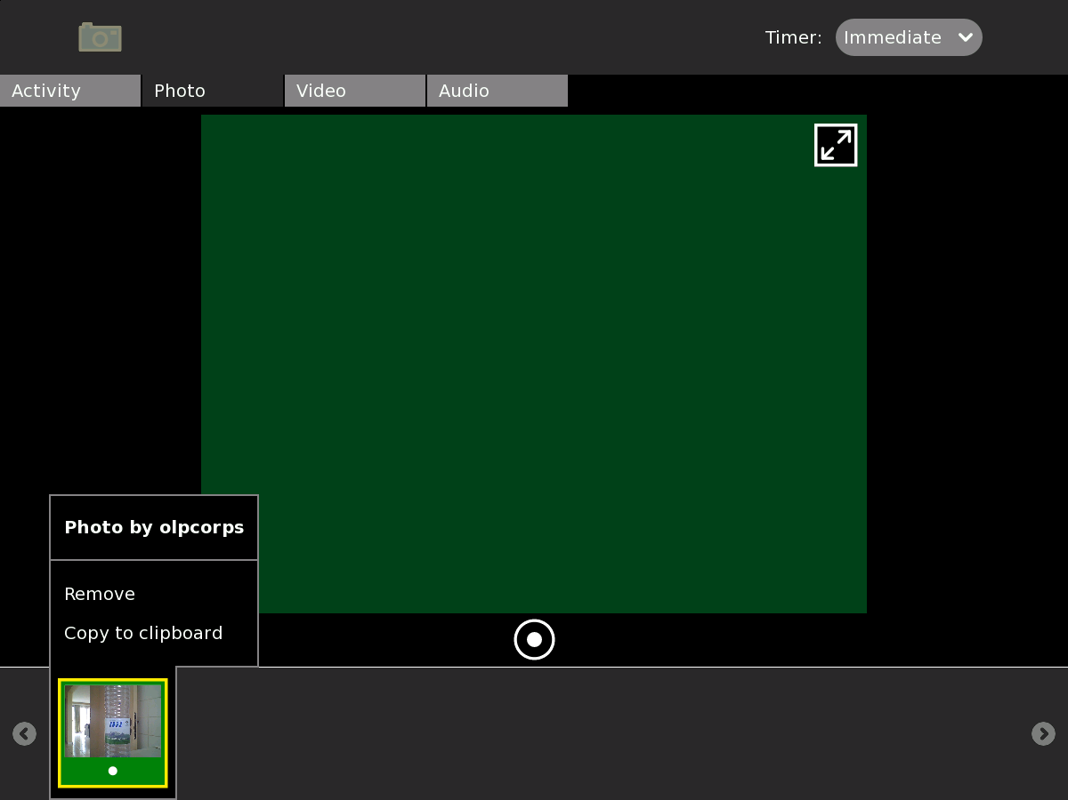

**1.** Open the Record Activity C:\Documents and Settings\Julia\Local Settings\Temporary Internet Files\Content.Word\Screenshot_1_2_3_4.png

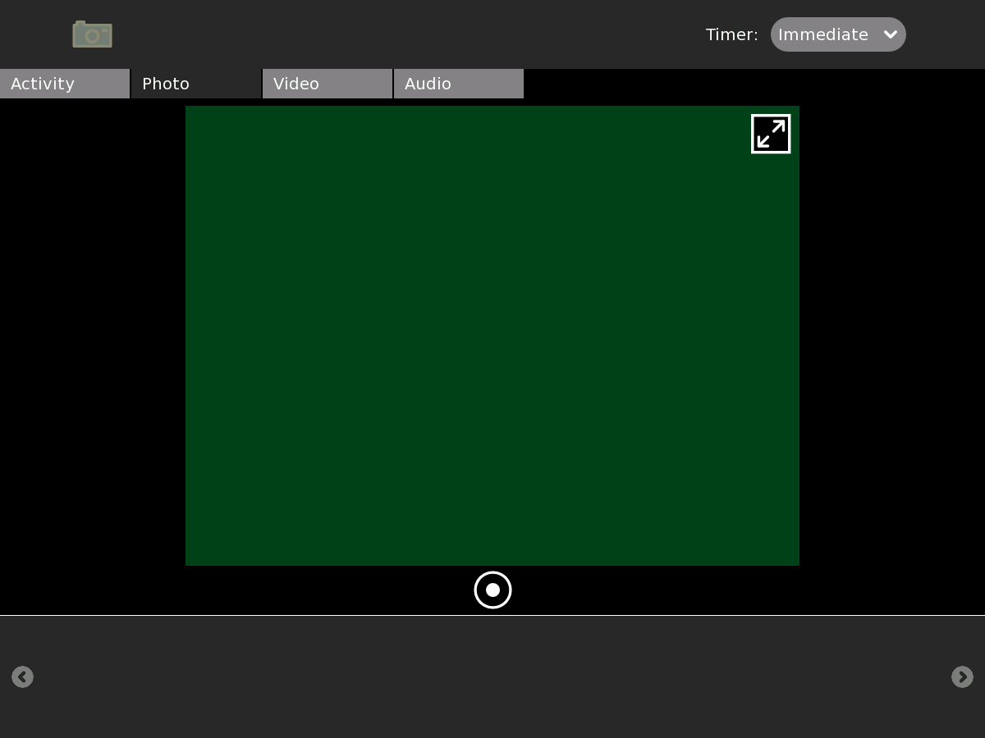

Just follow these steps:

Click on photo

Click here to take your photo photophotpicture

**3.** If you did it right you should see this flash on the bottom-left corner of your screen:

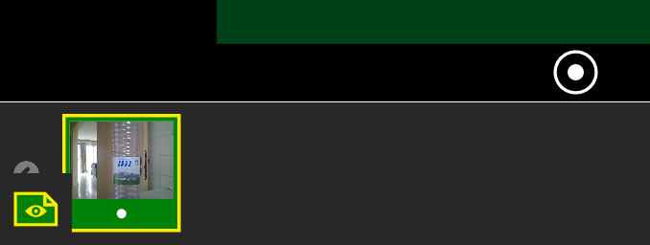

**4**. Go back to ‘Home’ by clicking this button C:\Documents and Settings\Julia\Local Settings\Temporary Internet Files\Content.Word\Screenshot_1_2_3_4.png either on your keyboard or frame and open Write C:\Documents and Settings\Julia\Local Settings\Temporary Internet Files\Content.Word\Screenshot_1_2_3_4.png Once you have Write open click on the Frame key on the top right of your keyboard: . Once you do this you should still see the small image on the bottom-left of your screen. Click on this and drag it to an open space.

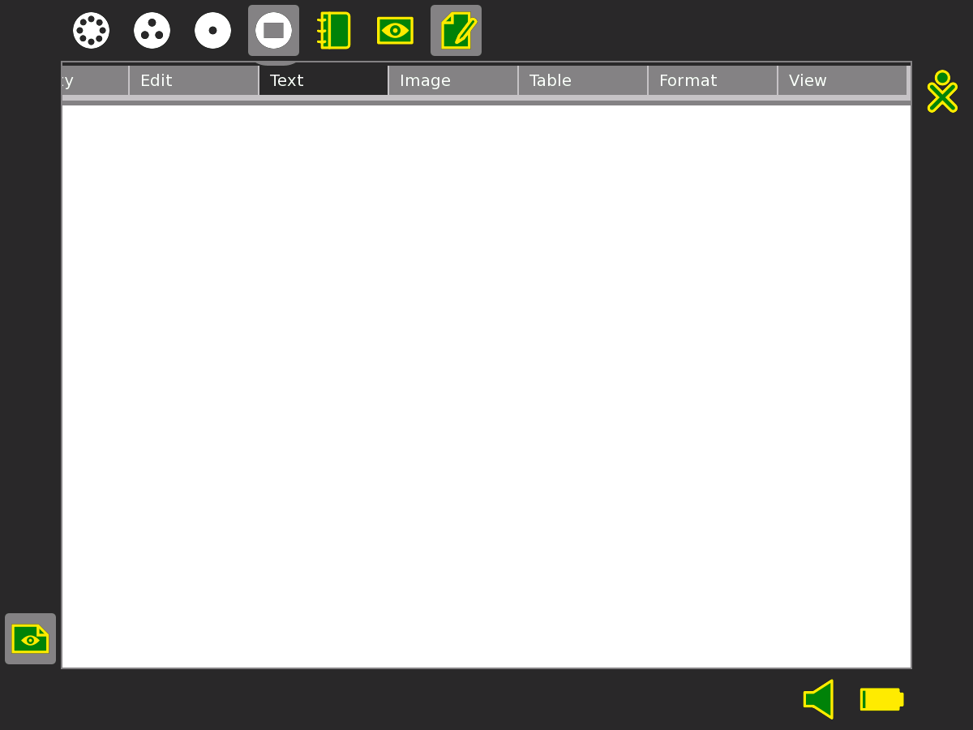

**5**. After a few seconds, you should see your picture now in Write C:\Documents and Settings\Julia\Local Settings\Temporary Internet Files\Content.Word\Screenshot_1_2_3_4.png. Remember to close the Frame (you do this by clicking the same button you clicked to open it ). Now you can start writing by just clicking then typing. You can move your text wherever you want on the page by using “enter” or “spacebar” on your keyboard.

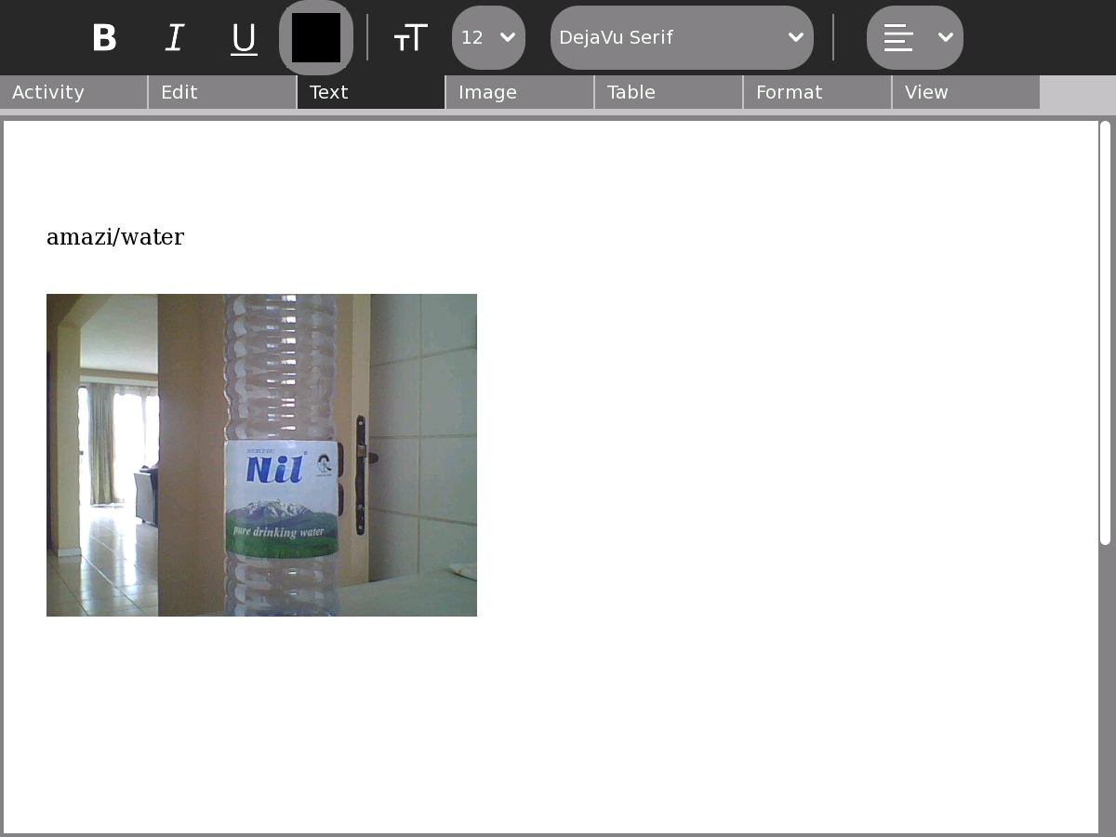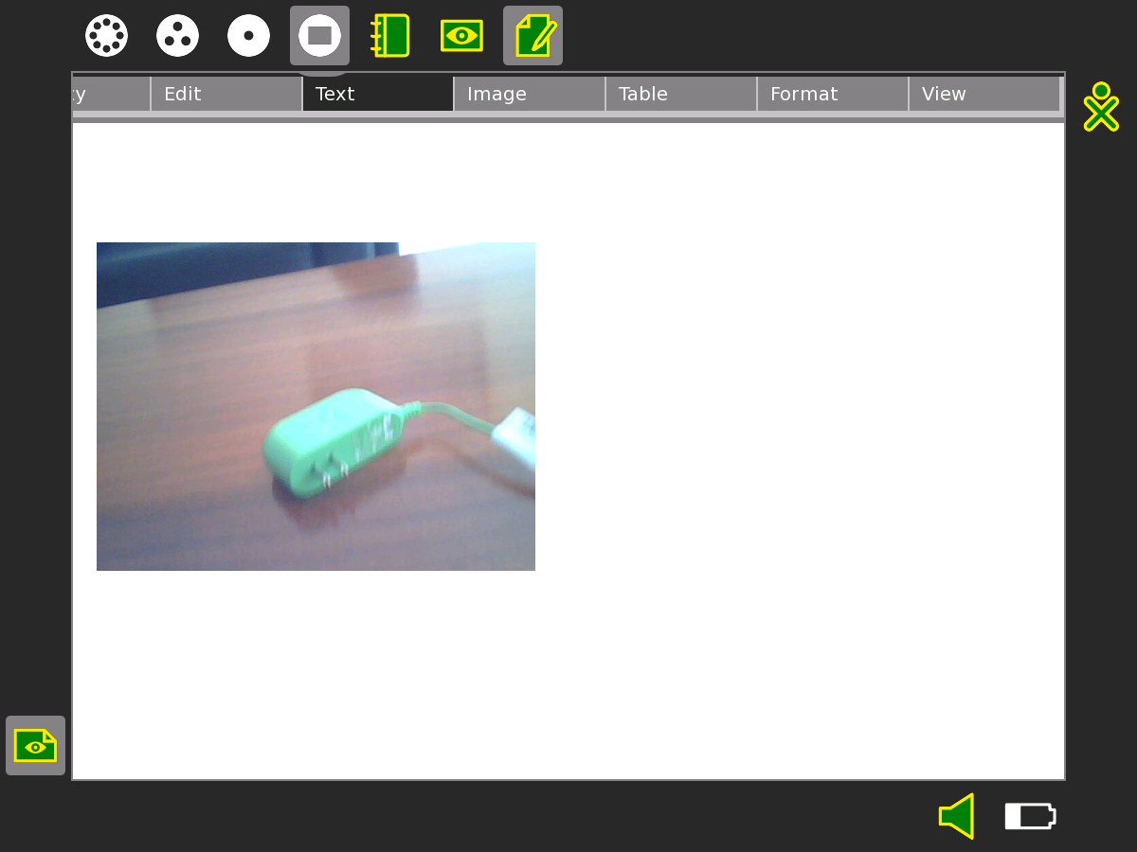

To change the size or location of your picture, just click on it once. You will see small grey boxes around it.

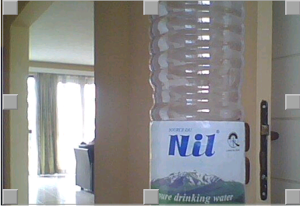 To move it, put your mouse in the middle, click and drag. To change the size click on the grey box in the corner, keep holding down and drag inward or outward, depending if you want it smaller or larger.

**Now let’s go deeper!**

C:\Documents and Settings\Julia\Local Settings\Temporary Internet Files\Content.Word\Screenshot_1_2_3_4.pngC:\Documents and Settings\Julia\Local Settings\Temporary Internet Files\Content.Word\Screenshot_1_2_3_4.png

The good thing about a project is that it allows you to really focus on one thing. The students then have to think really deeply and be creative. As a way of going deeper in this project let’s think about how we would include other types of words in our dictionary like:

Verbs: a word showing (running, shouting, thinking)

Adverbs: a word showing action but ending in –ly (slowly, quickly)

and

Adjectives: a descriptive word (beautiful, nice)

Here are some examples

But remember to let the students figure out how to represent these words on their own.