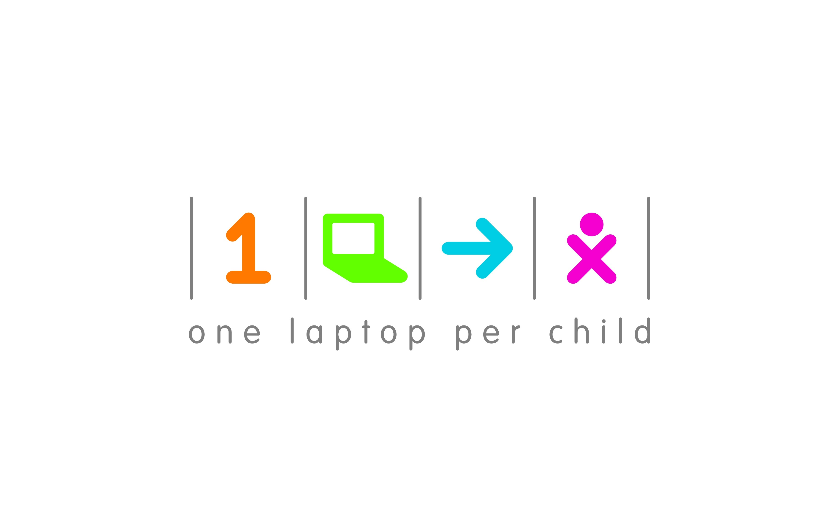
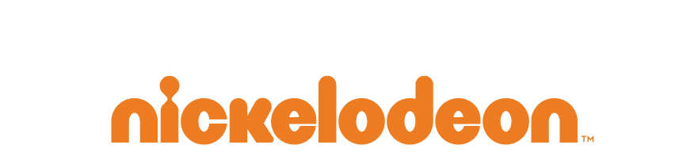

Nickelodeon Latin America Partners with
One Laptop Per Child to Support Children’s Education

Through The OLPC Digital Explorer Program, Kids In Latin America Will Compete In An
International Contest Focused On Creating A Better Environment

Winner will travel to Nickelodeon’s HALO Awards in Fall 2011

Miami, Fl. July 14th, 2011 – Nickelodeon Latin America today announced that it has partnered with One Laptop Per Child (OLPC), a nonprofit organization whose mission is to help provide every child in the world access to a modern education.”

Elementary school children across Latin America, who are already part of the OLPC Digital Explorer program via their OLPC-XO laptops, will be challenged to develop multi-media content in an international contest focused on creating a better environment. The winner of the competition will be awarded with a trip to Nickelodeon’s Halo Awards, a show where celebrities give awards to amazing, accomplished and inspiring kids who work hard to make the world a better place.

This initiative is in line with OLPC’s desire to enable a generation of children to think critically, connect to each other and the world’s body of knowledge, and to create conditions for real and substantial economic and social development. Nickelodeon and OLPC will work together to leverage the advantages of the XO laptop in elementary school education and promote strategies for increased access to laptops and connectivity in Latin America.

"We are delighted to partner with One Laptop Per-Child for this important initiative,” commented Mario Cader-Frech, Vice President of Public affairs and Corporate Social Responsibility for MTV Networks Latin America and Tr3s: MTV, Música y Mas. “OLPC has done an outstanding job of bringing technology and computer-assisted learning to kids around the world. This contest not only inspires children in the region to make a difference in their communities but also helps them to develop new skills that will prepare them to become productive members of tomorrow’s workforce. “

“OLPC is constantly looking to engage with private sector companies to achieve mutual objectives for children and education, said Rodrigo Arboleda, CEO of OLPC-“ Nickelodeon joins a distinguished group of OLPC partners that includes General Mills, Marvell, Procter&Gamble and BHP Billiton, all devoted to bringing quality education worldwide".

###

About Viacom International Media Networks
Viacom International Media Networks (VIMN), a unit of Viacom Inc. (NYSE: VIA, VIA.B), is comprised of many of the world’s most popular multimedia entertainment brands, including MTV, Nickelodeon, Comedy Central, BET, non-premium Paramount branded channels, VH1, VIVA, MTVNHD, Tr3s: MTV, Musicá y Mas, TMF (The Music Factory), COLORS and Game One. Viacom brands are seen globally in more than 600 million households in 160 territories and 34 languages via 166 locally programmed and operated TV channels and more than 550 digital media properties. VIMN’s diverse holdings also include interests in television syndication, publishing, home video and licensing & merchandising.

About One Laptop Per Child
One Laptop Per Child (OLPC at http://www.laptop.org) is a nonprofit organization created by Nicholas Negroponte and others from the MIT Media Lab to design, manufacture and distribute laptop computers that are inexpensive enough to provide every child in the world access to knowledge and modern forms of education.

###

MTV Networks Latin America
Latin America
Axel Escudero
(5411) 5295-5270
axel.escudero@mtvstaff.com

Miami & Colombia
Marimar Rivé
(305) 938-4910
marimar.rive@mtvstaff.com

Argentina & Chile
Vanina Rodríguez
(5411) 5295-5272
vanina.rodriguez@mtvstaff.com

Mexico
Erick Zermeño
(5255) 5080-1729
Erick.zermeno@mtvstaff.com

Guillermo Reyna
(5255) 5080-1766
guillermo.reyna@mtvstaff.com

