One Laptop per Child

Holmes Elementary School
A project supported by Knight Foundation and Miami-Dade County Public Schools

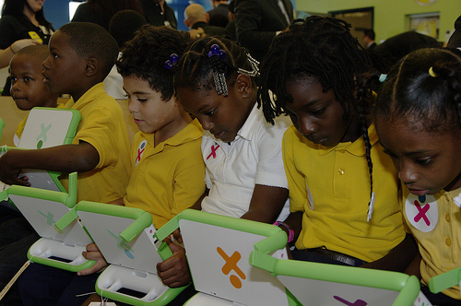
One Laptop per Child (OLPC) is a non-profit organization founded in 2005 with a goal of transforming primary school education by ensuring that every child has access to a connected laptop computer (the “XO laptop”). OLPC’s mission is to provide every child in the world with access to new channels of learning, sharing and self-expression.
In early 2011, Knight Foundation became interested in the work of OLPC. Knight Foundation is working around the world to support transformational ideas that emphasize innovation and engage communities.

Miami is an area where the Knight Communities Program is working. Despite being one of the nation’s most vibrant metropolises, Miami is a community in need of transformational change. Miami is home to many of the best and worst performing public schools in the country. By partnering with OLPC, Knight has provided the students at Holmes Elementary school in Miami with access to low-cost, low-power, connected XO laptops to enhance learning and development.
Holmes Elementary School serves a majority of the students in Liberty City, a deprived neighborhood in Miami. Student demographics are 98% of students African American and 97% receive free or reduced lunch.

Since the school’s reopening in 2007, Holmes has been unable to show the academic growth necessary to satisfy both state and federal requirements. As a result, Holmes is in danger of having to close its doors at the end of this school year if tremendous gains are not achieved.
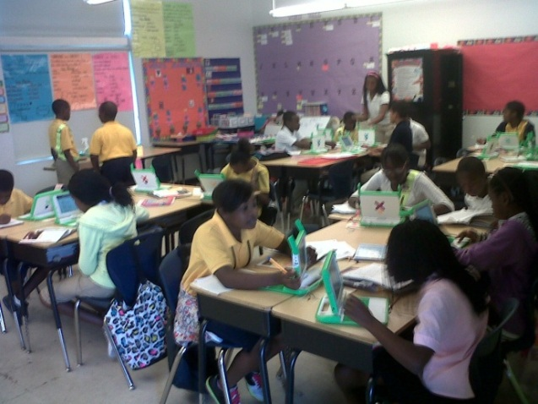
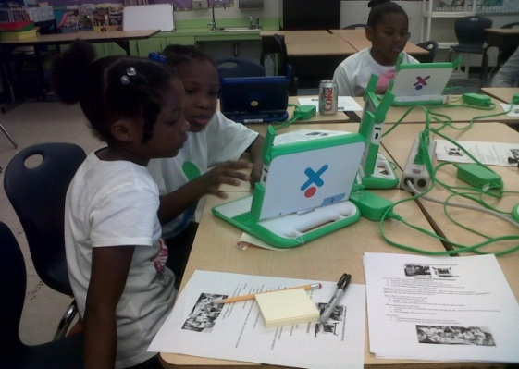
In early 2012, nearly six hundred students at Holmes Elementary School received their very own XO laptop thanks to Knight. With the support of Miami-Dade County Public Schools, every laptop is now wirelessly connected. Each day, students now have access to the internet, district approved intervention programs and over two hundred Activities currently available free of charge through the XO laptop’s operating platform.
School district officials, Knight and OLPC are witnessing the transformation of Holmes Elementary School. This project has grabbed the attention of the national media, elected officials and business leaders throughout the world. The traditional teacher-led classroom is slowly disappearing as collaboration is now the name of the game. Together, teachers and students are working to create projects and engage thoughtfully in the educational process.
Beyond the school day, students have access to a variety of extracurricular opportunities including morning XO clubs and vacation enrichment programs. In these arenas, students have the opportunity to program robots, use sensors to cause reactions and create advanced mathematical equations to manipulate computer images.
Knight’s partnership with OLPC is a crucial piece of a community effort to level the playing field for the students at Holmes Elementary School. What was a pilot project for the U.S. is now a model for other developing projects throughout the country.

For exciting media coverage on the Holmes project, visit:
http://miami.cbslocal.com/2012/01/27/students-at-liberty-city-school-get-free-laptops/
http://www.miamiherald.com/2012/01/27/2612304/miami-dade-students-in-liberty.html
http://miamitimesonline.com/holmes-students-rewarded-with-laptops/
http://www.knightfoundation.org/press-room/press-mention/parent-parent-one-laptop-child-miami/

