LESSON PLAN
SHAPES AND SHADES
Gcompris

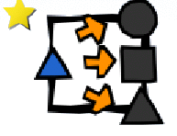
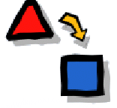
CLICK:

GOALS:
- To develop the observation skill of shapes.

CONTEXTUALIZATION: To go out side of the class, under the sun and observe the shade of the objects and people. The kids can do the objects contour on the ground.

HOW TO PLAY: Drag and drop the shapes in the respective shades.

