

LESSON PLAN

ALPHABET

Gcompris

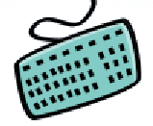

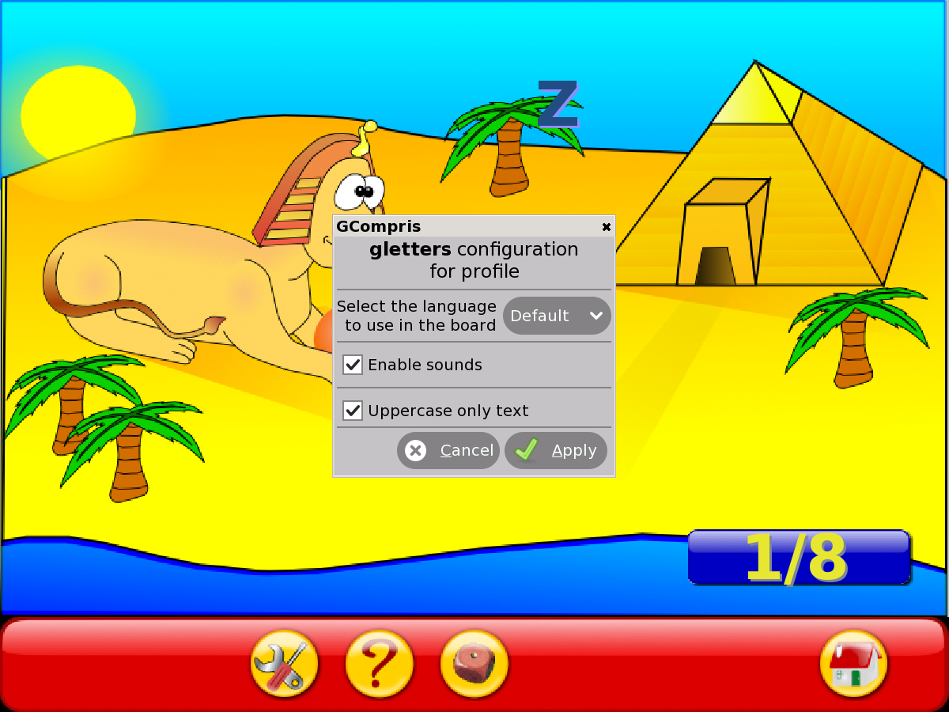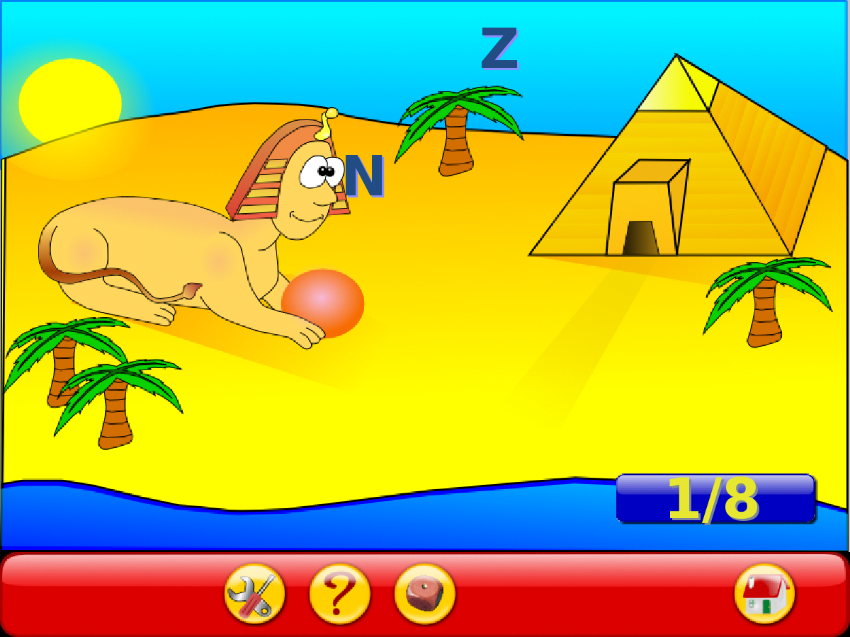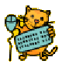

**GOALS:**

* To get familiar with English alphabet (visual representation and the sound of the letters)
* To get familiar with laptop keyboard, doing the association between the letter on the screen and on the keyboard.

**CONTEXTUALIZATION:** Say loud or sing a song for the English alphabet.

**HOW TO PLAY:** Type the falling letters before they reach the ground.

Click to enable the sound and uppercase

**CLICK:**