getting started
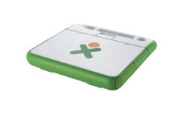
Place the laptop with the XO icon face up and with the handle facing away.
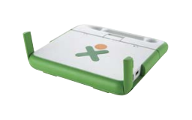
Lift the ears to release the latches.
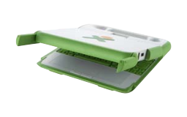
Lift the display up from the keyboard along the seam.
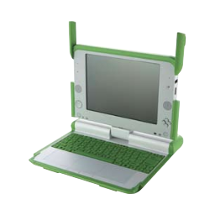
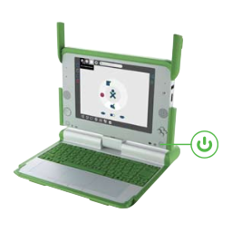
Push the power button to turn on the laptop.
(To turn off the laptop, hold down the power button for 10 seconds.)

Connecting
There are three ways to connect to the Internet:
wireless access point (WiFi hotspot);
“School Server” mesh network;
“simple” mesh network, which lets you collaborate directly with other XOs.

You make your connection from the Neighborhood view. Your current connection status is shown on the Home view. (The XO was designed for wireless access because in the developing world, wireless is actually the fastest, most reliable, and least expensive way to connect.)
Step 1: Go to the Neighborhood view
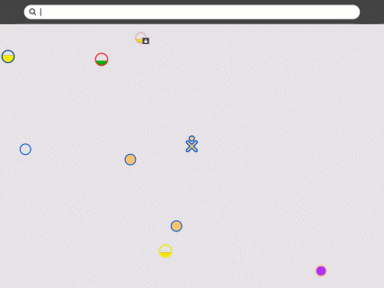
Go to the Neighborhood view to connect to an access point. The Neighborhood view is accessed by pressing the round key with eight dots,  found in the upper-left corner of the keyboard.
Step 2: Choose an access point
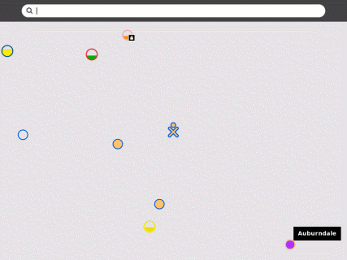
Networks (access points) are represented by circles on the Neighborhood view. Networks can be identified by hovering over the circles: an access point is identified by its name (ESSID); a mesh-portal point is identified by its channel number (1, 6, or 11). You can also search for an access point by name in the search bar at the top of the page.
Signal strength is indicated by the fill-level of the circle. The color of the circle is based upon the name of the access point. Networks that are locked are identified by a badge.
Step 3: Activate a connection
To activate your network connection, click once inside the circle that corresponds to your chosen access point. (To “click”, press once on the left-hand touchpad button—the button with the × symbol at the front of the touchpad.) While the XO is trying to establish the connection, the inside of the circle will blink. Once the connection is established, the outside of the circle will turn white. If for some reason the connection failed, the circle will stop blinking. Sometimes it is necessary to try several times before the connection is established.
If the access point requires a key, you will be prompted. Note that different types of access points require different types of keys: be sure to select the correct type from the pull-down menu that is presented. Some access points (such as the Apple Extreme®) will only work with a hexadecimal value. If you have a password or passphrase, go to Hex Converter to get the hex key. Also, with the Apple Extreme you need to set “shared key”. Most other access points prefer the “open key” setting when using WEP.
Currently, we do not support WPA-enabled WiFi access points; we anticipate including WPA support in early 2008.
Step 4: Checking the connection
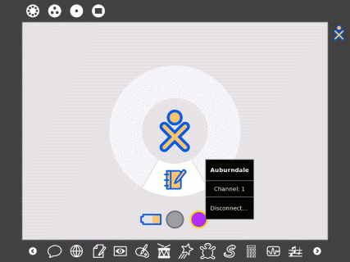
Go to the Home View—by using the key with one circle found in the upper-left corner of the keyboard—to check your connection. By hovering over the circle icon, you will find details about your connection status.
If you don't specify a network, the XO will attempt to join a simple mesh network, enabling you to collaborate with other XOs, but not access the Internet.
For more information about connecting, please see the Support page in our wiki.

You connect to the Internet from the Neighborhood view.

Access points are represented by circles. The fill level indicates signal strength.

Access points that require keys have a “locked” badge.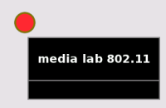
The name of the access point is displayed when you hover over it.

You connect by “clicking” in the center of the circle. The center of the circle will blink while the laptop is trying to connect.

Once you are connected, the rim of the circle turns white. (If the attempt to connect fails, the circle will stop blinking, but the rim will not turn white. Try again—it sometimes takes 2–3 tries to connect.)
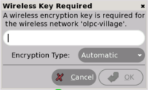
You will be prompted if the access point requires a key.
For more information about connecting, please see the Support page in our wiki.

activities


The XO laptop runs on Linux, a free and open-source operating system. OLPC's commitment to software freedom gives children the opportunity to use their laptops on their own terms. Children and teachers have the freedom to reshape, reinvent, and reapply their software, hardware, and content. There is even a button located on the keyboard that allows children to view the programming behind many applications. The XO laptop's revolutionary interface, Sugar, also promotes collaborative learning.
Browse
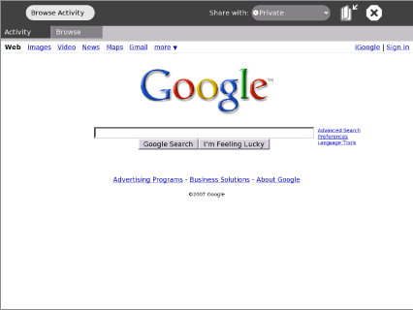
Browse is a simple Web application that allows children to access and search the Internet and share bookmarks among their friends. (See the Browse page in the wiki for more information.)
TamTamMini
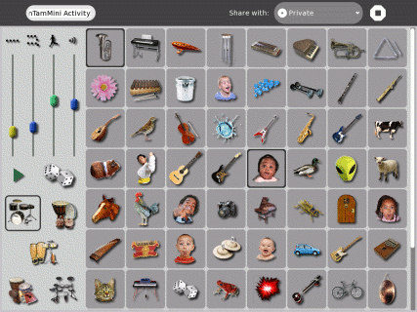
Simple enough to be used by even the youngest ages, TamTam Mini is a fun, powerful way to perform music and play instruments. (See the TamTam page in the wiki for more information.)
Chat
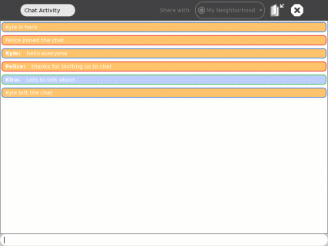
The Chat activity provides a simple environment for discussion, whether it is between two individuals or an entire classroom. (See the Chat page in the wiki for more information.)
Memorize
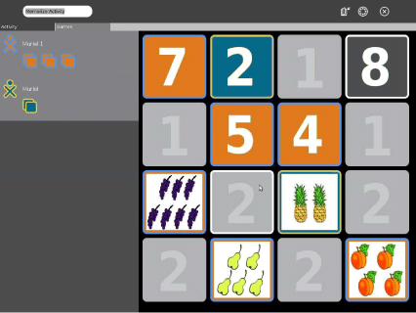
Memorize is the classic memory game of finding and matching pairs with a twist: a pair can consist of any multimedia object, such as images, sounds and text. The memory game allows children to play existing games as well as create new ones themselves. (See the Memorize page in the wiki for more information.)
SynthLab
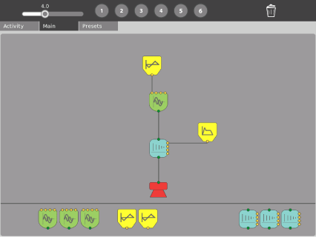
Designed for older children who are ready to venture into more sophisticated sound design, SynthLab is a mini-lab for acoustic- and electronic-circuit construction. (See the TamTam page in the wiki for more information.)
TamTamEdit
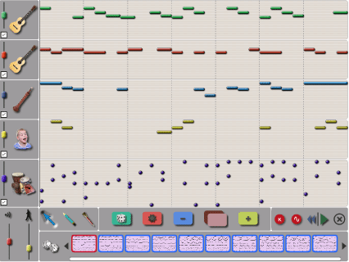
TamTam Edit is an intuitive environment for composing music. Children can create, modify, and organize notes on virtual “tracks”, which allow for virtually limitless variations in musical styles. (See the TamTam page in the wiki for more information.)
TamTamJam
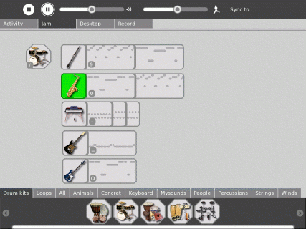
TamTam Jam is a fun, powerful way to perform music, play multiple instruments, and collaborate musically with other children. (See the TamTam page in the wiki for more information.)
Record
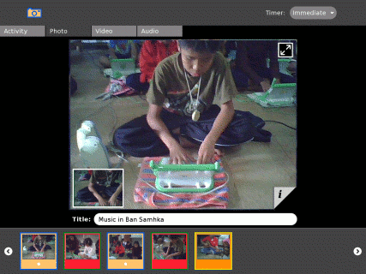
The Record activity provides a simple way for children to take pictures, view slide shows, and record video and audio—all content that can be shared via the mesh network. (See the Record page in the wiki for more information.)
The Journal
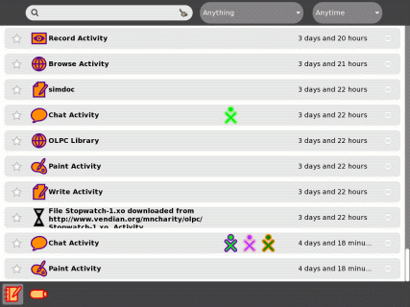
The Journal activity is an automated diary of everything a child does with his or her laptop. The Journal can be used by children to organize work or revisit a past project, and by teachers and parents to assess a child's progress. (See the Journal page in the wiki for more information.)
Measure
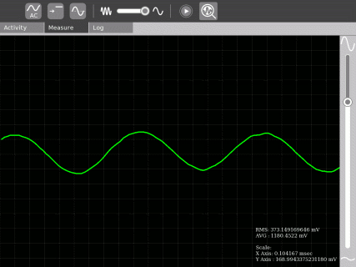
Measure is a tool that allows children to explore and learn by connecting and observing physical phenomena and real-world events. With it, children can measure and log data and create graphs. (See the Measure page in the wiki for more information.)
NewsReader
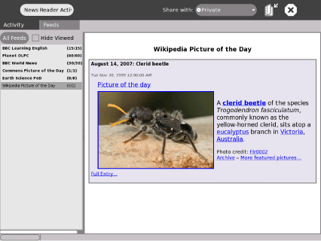
The NewsReader activity provides an interface for viewing news (RSS) feeds. (See the News Reader page in the wiki for more information.)
Draw
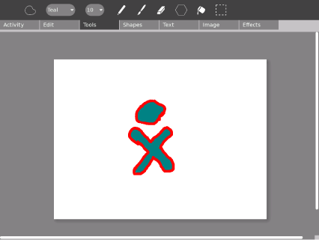
The Draw activity provides a canvas for a child or a group of children to express themselves creatively. Children can draw free-form images with a paintbrush and pencil, and use the dedicated toolbar to play and experiment with shapes. Text support, image import functionality, and an interactive placement system give children limitless ways to explore their creativity. (See the Draw page in the wiki for more information.)
Pippy
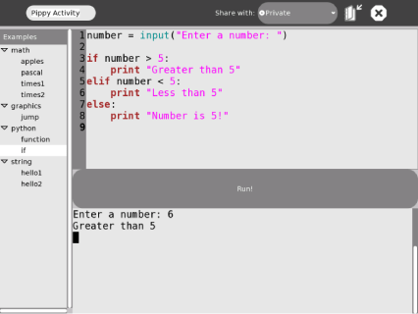
Pippy is a simple and fun introduction to programming in Python, the dynamic programming language underlying much of the software on the laptop. (See the Pippy page in the wiki for more information.)
Distance
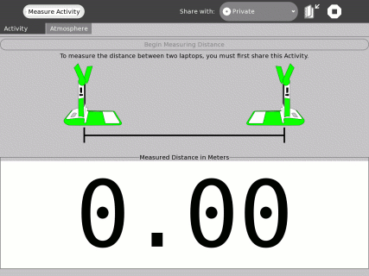
You can measure the distance between two laptops by measuring the length of time it takes for sound to travel between them. Along with the measure and record activities, there are many ways to use the laptop to explore the physical environment. (See the Distance page in the wiki for more information.)
Turtle Art
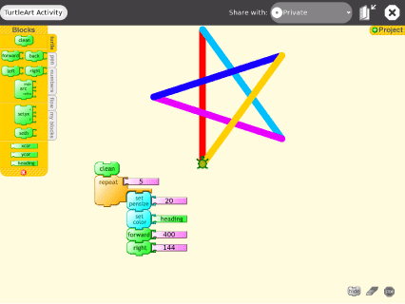
Turtle Art lets children program a Logo “turtle” to draw colorful and complex artwork. Simple programming elements easily snap together, allowing children to bring their art to life. (See the Turtle Art page in the wiki for more information.)
Write
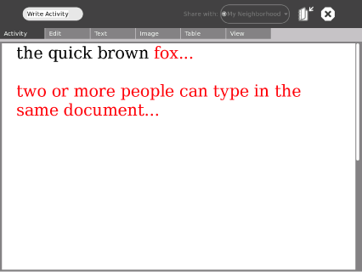
Write is a basic text editing application featuring straightforward tools and a simple interface. It provides an easy way for children to write a story, craft a poem, or complete an essay, as well as more advanced features like image insertion, table creation, and layout operations. It also features collaborative real-time editing, so a group of children can work together to edit text easily and seamlessly. (See the Write page in the wiki for more information.)
Etoys
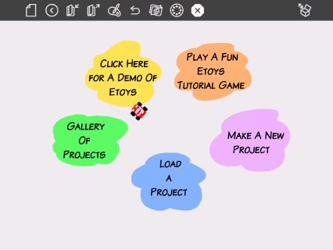
Etoys is a media-rich authoring system aimed at helping children learn by doing. They can explore their ideas by creating models, simulations, and games complete with text, graphics, sound, and video. Children can also share desktops with other Etoys users in real time, encouraging immersive mentoring and play. Etoys has a worldwide community of users and developers who are working to create content, curriculum, and examples. (See the Etoys page in the wiki for more information.)
Read an eBook
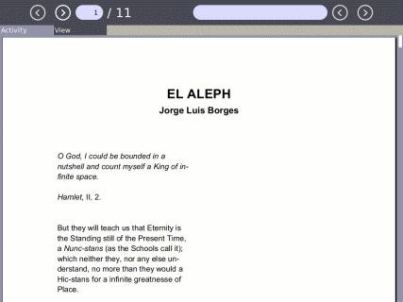
The laptop has a built-in eBook reader: the display rotates 180 degrees around and folds down on the keyboard, which enables you to hold the laptop like a book to read. The screen folds over the keyboard and the screen rotates, enabling you to read a book while holding the handle. Read your favorite book on the laptop while sitting outdoors in the sunlight. (See the Read page in the wiki for more information.)
Calculate
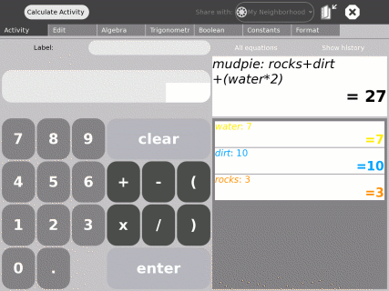
Calculate provides a generic calculator with a simple, straightforward interface. It is designed to be intuitive and readable enough for even the youngest children to use, while also supporting more complicated mathematics. (See the Calculate page in the wiki for more information.)
Downloads
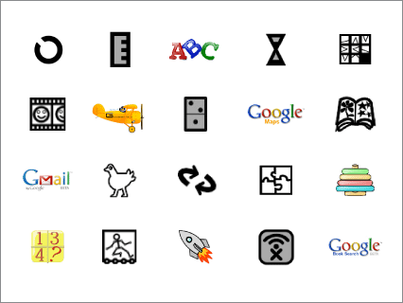
Along with the applications built into the XO laptop is an ever-growing array of downloadable content and built-in access to popular Web-based applications. This includes Google applications, SimCity, GCompris (a suite of award-winning educational software for children), and hundreds of other applications. There are currently thousands of software developers around the world developing content for the XO. For more information, visit http://wiki.laptop.org/go/Activities.
To download and install a new activity: (1) start the Browse activity on your XO; (2) goto http://wiki.laptop.org/go/Activities webpage; (3) click on the .xo bundle next to the word Download:, e.g., click on Implode.xo to download Implode; (4) open the Journal activity on your XO; (5) “resume” the downloaded activity from the Journal entry; the new activity should both launch and install on your taskbar.

inviting
Step 1: Launch an activity
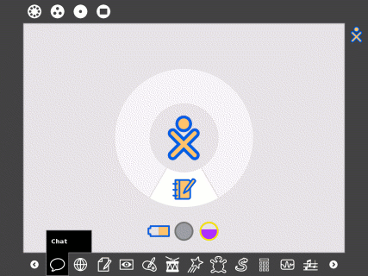

Before you issue an invitation, you should launch an activity—Chat in this example—by clicking on the taskbar icon.
Step 2: Leaving Chat
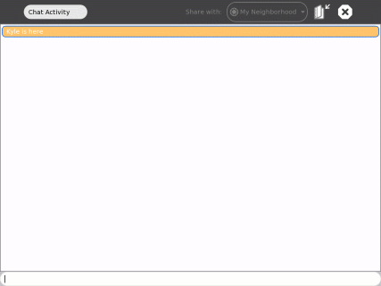
You'll have go to either the Group view or the Neighborhood view to issue invitations.
Step 3: Find a friend
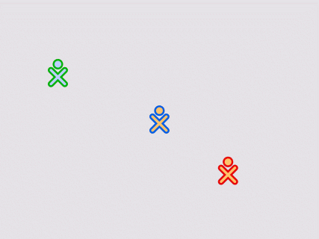

In this example, we use the Group view.
Step 4: Invite a friend
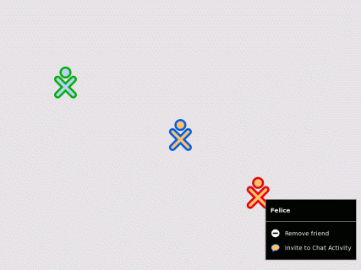
Hovering over a friend's icon will bring up the invitation menu. Note that it says “Invite to Chat Activity”, since Chat is your currently selected activity.
Step 5: Invite another friend
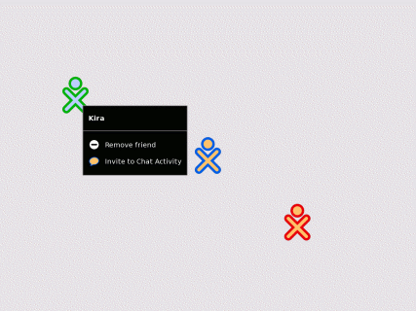
Most activities let you invite more than one friend to participate.
Step 6: Receiving the invitation
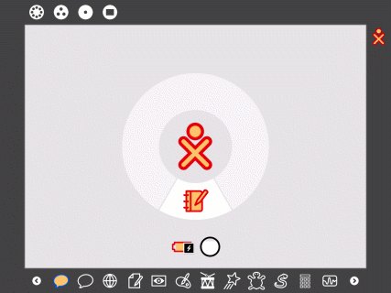
Your friends receive an invitation on their activity taskbars (found on the Frame). In the figure, see the second Chat icon (in your colors, since you are the one who sent the invitation).
Your friends accept the invitation by clicking on these colored Chat icons on their taskbars.
Step 7: Multiple invitations
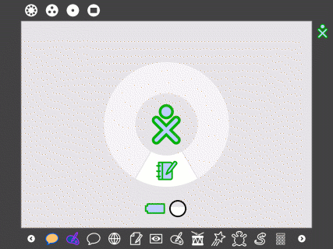
You can have more than one invitation pending.
You need not accept an invitation.
Step 8: Working together
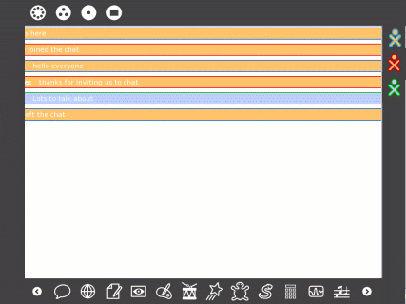
Once the invitations have been accepted, the shared activity is joined. (Note that the icons representing everyone in the Chat appear on the Frame.)

You invite collaborators from either the Group view or the Neighborhood view.
sharing
From the mesh view, you see other XOs with whom you can share documents and activities. (Activities and documents being shared by others show up as icons and network access points are represented by circles.)
Step 1: Launch an activity
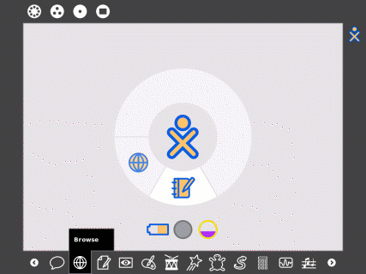

Before you share, you should launch an activity—in this case Browse—by clicking on the taskbar icon.
Step 2: Select the Activity Tab
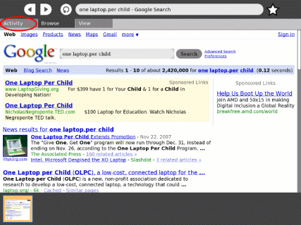
The sharing menu is on the Activity Tab.
Step 3: Share with Neighborhood
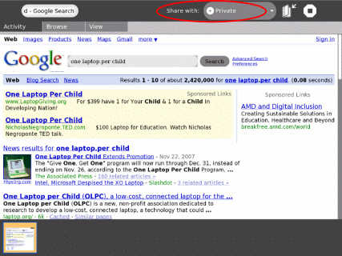
Select “share with neighborhood” on the pull-down menu.
Step 4: Sharing
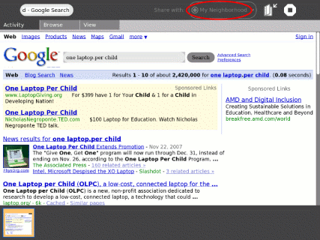
Once “share with neighborhood” is selected, you are sharing.
Step 5: The mesh view
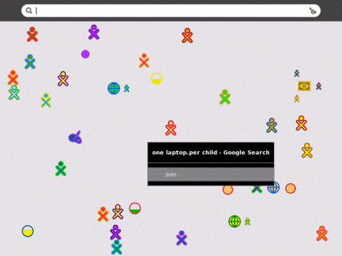
Your Browse session will appear to everyone on the mesh view.
Others can join your Browse session clicking on the browse icon in the mesh view.
Step 6: Sharing bookmarks
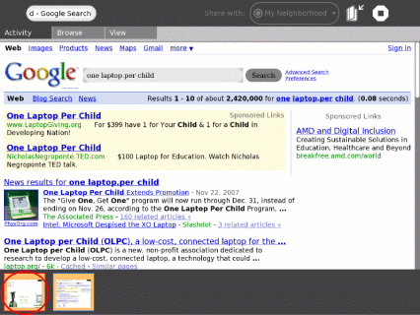
Browse shares by sharing bookmarks. Whenever anyone bookmarks a page in the shared session, everyone sees the bookmark in their browser tray. (Note that you create a bookmark by clicking on the star in the Browse menu—see Step 2 above.)
Step 7: Following a shared bookmarks
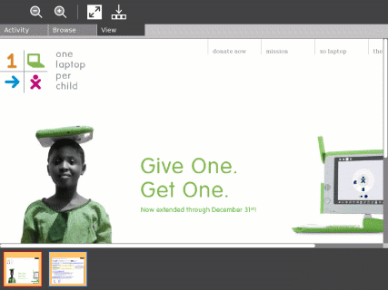
The shared bookmarks are clickable, hence everyone can surf the web together.
Sharing pictures
Sharing books
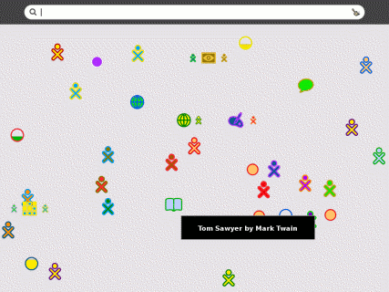
The read activity lets you share books on the mesh.
Sharing equations
The calculate activity lets you share variables and equations.
Sharing fun
Most games have multiplayer modes that are played together over the mesh.
Sharing music
TamTam Jam lets you play music with other laptops, sharing a common drum beat.
You share from the Neighborhood view.

The journal
The Journal activity is an automated diary of everything a child does with his or her laptop. The Journal can be used by children to organize work or revisit a past project, and by teachers and parents to assess a child's progress.
The Journal is also used to access external media (USB sticks, etc.); delete files; and access the backup system (for those of you connected to a School Server).
The Journal features
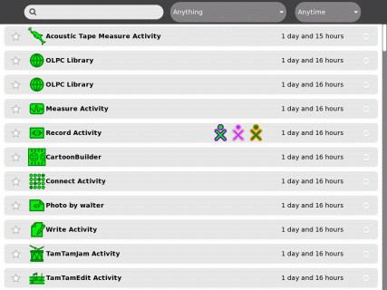
The Journal keeps a record of all of your activities and the things your create, e.g., photos, drawing, writing, etc. You can search for individual items in your Journal or sort the entries by type or date. You can also click on an entry to get a detailed view. Finally, you can resume an activity by clicking on the small gray icon at the far right of the entry.
USB storage devices
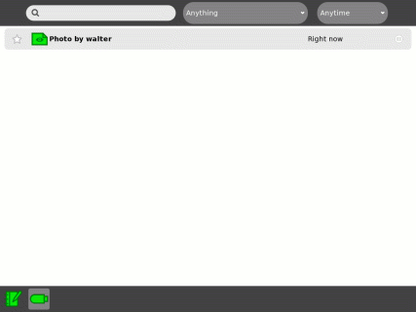
Clicking on the USB icon shows the content of the device as Journal entries. Journal entries can be “dragged” onto the USB device and objects on the USB device can be “dragged” into the Journal.
Removing USB storage devices
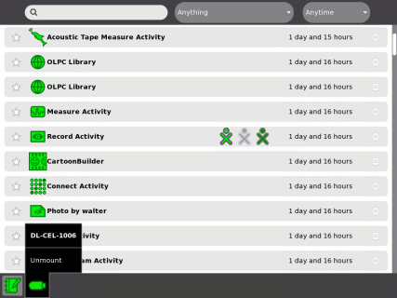
Hovering over the USB icon brings up an option to unmount the device.

You access the Journal using the Search key or from the Journal icon on the Home view.
ebook mode
The XO laptop transforms into an ebook.
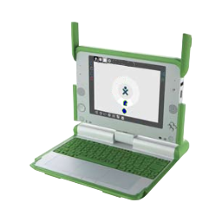
Begin by positioning the screen vertically (at a right angle to the base).
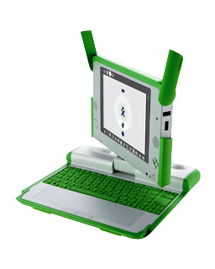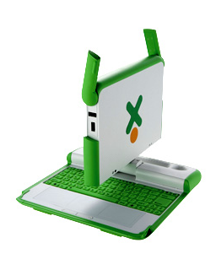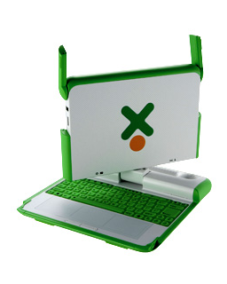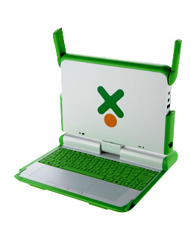
Rotate the display until the screen is facing away from the keyboard.
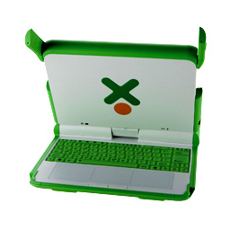
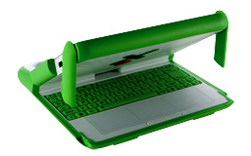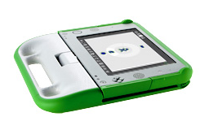

The game controllers can be used to scroll the display
To maximize battery life, turn the backlight off by pressing the lower-brightness key 4–5 times before entering ebook mode. (To restore the backlight, press the raise-brightness key 4–5 times.)

Home view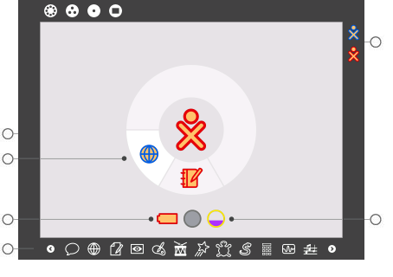
The Home view is used for launching activities and accessing the Journal. (Mouse over the circles in the figure above for more detailed information about the Home view.)

You access the Home view using this icon/key.

Group view 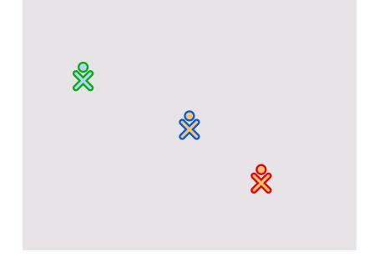

The Group view shows the child, their friends, and their activities, such as chat or a shared project. Every child is represented by a different color.
You access the Group view using this icon/key.

Neighborhood view 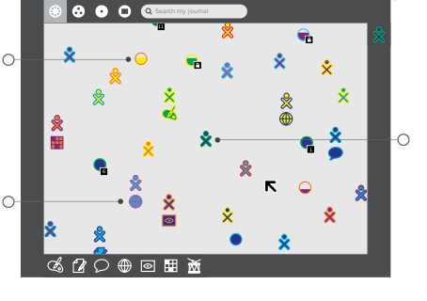
The Neighborhood view is used for connecting to the Internet and collaborating with others. (Mouse over the circles in the figure above for more detailed information about the Neighborhood view.)
You access the Neighborhood view using this icon/key.
Activity view 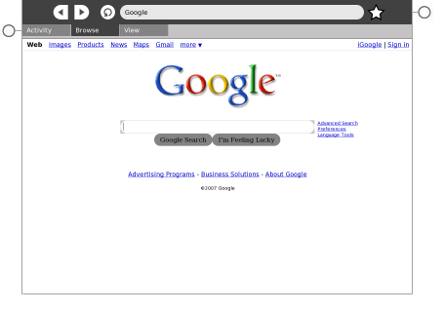
The Activity view displays the particular activity, or application, that a child is currently working within, such as Write or Draw. (Mouse over the circles in the figure above for more detailed information about the Activity view.)

You access the Activity view using this icon/key

Features
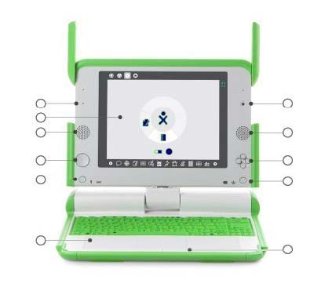
The XO laptop has built-in functionality for still and video photography, voice recording, and game playing. (Mouse over the circles in the figure above for more detailed information about XO features.)
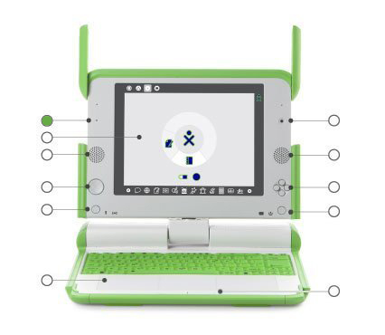
Built-in microphone
There is both a built-in microphone and an external microphone jack, which supports both AC and DC sources. As a privacy measure, there is an LED above the microphone that lights up whenever it is in use.
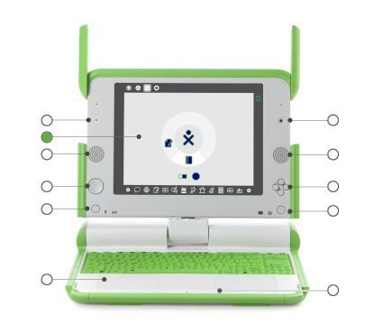
Backlit screen
The display functions in a full-color mode similar to other laptop displays and in an ultra-low-power, ultra-high-resolution, black-and-white mode that is readable in direct sunlight.
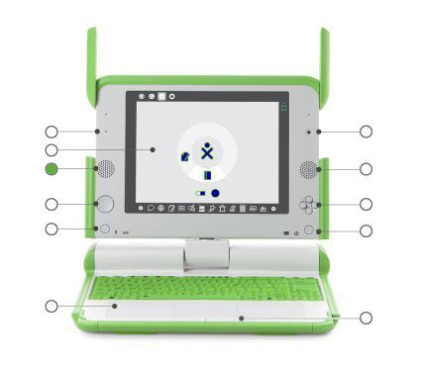
Built-in speakers
Internal stereo speakers and an amplifier provide a way for children to play music, videos, and anything they have recorded themselves. There’s also a jack for external headphones or speakers.
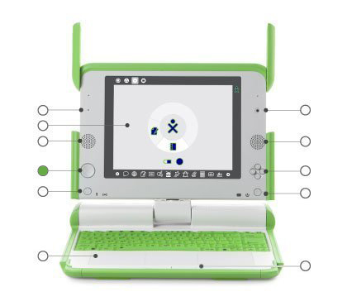
Game pad
There are two sets of four-direction cursor-control keys. These keys act as game controllers that can be used when the screen is folded down into e-book mode, creating a self-contained game player.
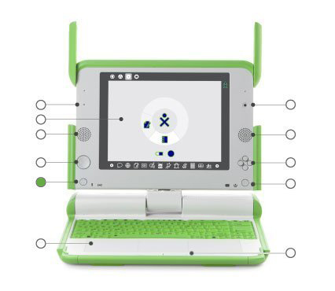Screen rotation
A button on the XO laptop’s display frame changes the orientation of the screen, so it can be viewed right-side-up from any direction.
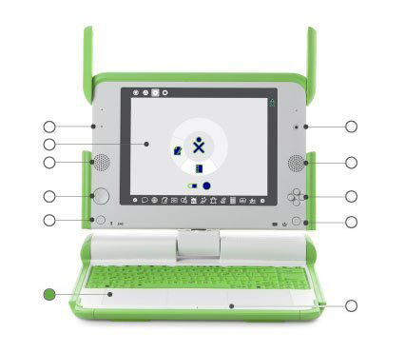Touchpad
The XO has a dual-mode touchpad. The center portion is capacitive: it used to move the cursor as you move your finger. The entire surface is also resistive: in the future, activities can be used with a stylus.
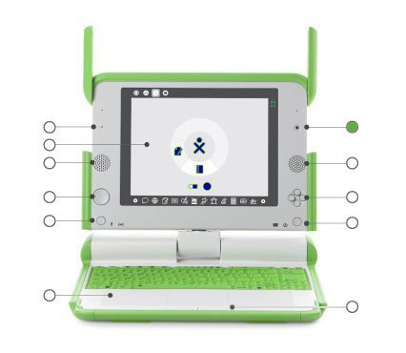
Built-in camera
The XO laptop has a built-in color camera to allow for still photography and video recording. As a privacy measure, there is an LED above the camera that lights up whenever the camera is on.
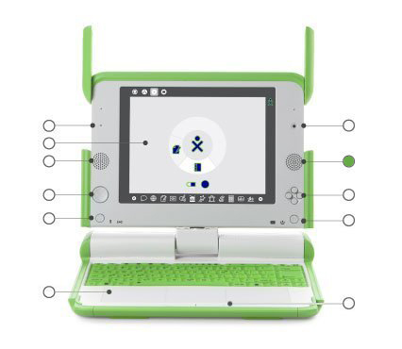
Built-in speakers
Internal stereo speakers and an amplifier provide a way for children to play music, videos, and anything they have recorded themselves. There is also a jack for external headphones or speakers.
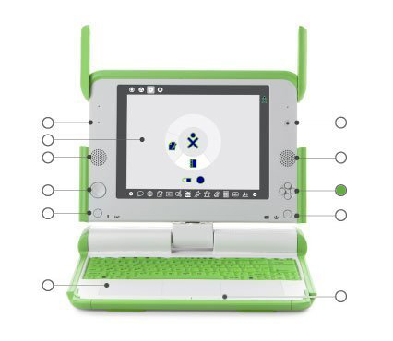
Game controller buttons
The game controller buttons can be used when the screen is folded down into e-book mode, creating a self-contained game player. The buttons are labelled with a circle, a square, a check, and an ×; these buttons are often used by actvities, e.g., the circle button can be used as the shutter for the camera in the Record actvity.
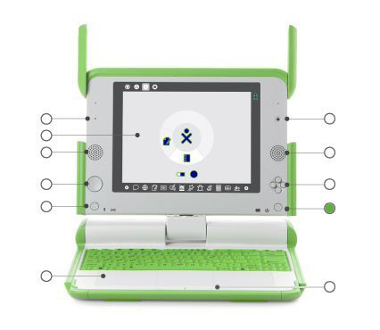Power button, indicators
From left to right: the battery-level indicator; the power indicator; and the power button
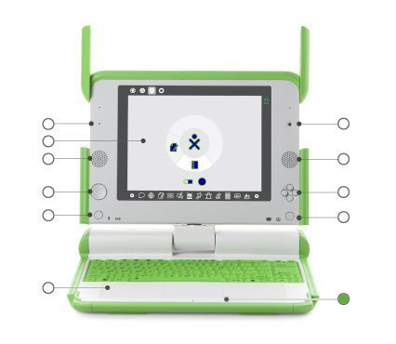Touchpad buttons
There are two touchpad buttons: one labelled with a × and the other with a circle. Whenever you are asked to “click”, you should tap the left-hand button (×) once. In the future, the right-hand button (o) will be used to bring up hover menus instantly. (We've tried to eliminate the need to “double click” throughout the interface.)

External ports 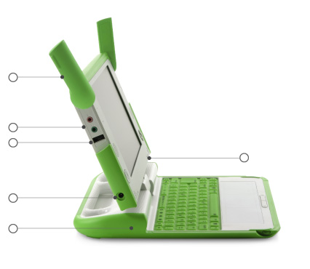
Along with offering superior connective capabilities, the XO laptop can work with a wide range of external devices. (Mouse over the circles in the figure above for more detailed information about XO features.
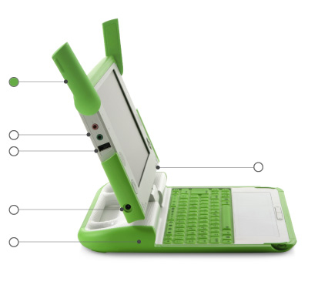Antennae ears
When the wireless antennae “ears” are rotated up, they are vastly superior to those of conventional laptops; when down, they keep dirt out of the connectors and act as a latching mechanism.
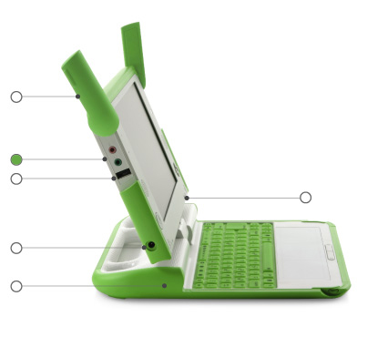External headphones and microphone jacks
Along with built-in speakers and microphone, the XO laptop features jacks for external headphones and an external microphone.
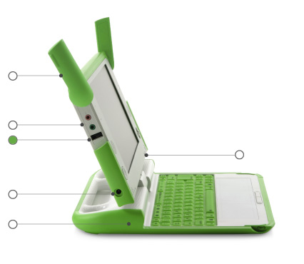USB/memory ports
The XO laptop features three external USB ports to support a variety of plug-in peripherals (one seen here and two others under the other “ear”).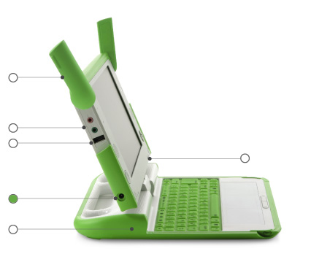 Power jack
The XO comes with a power cord that can be plugged into any 110-to-240-volt AC outlet for charging. The power jack also accepts DC power from a solar panel for charging the XO laptop’s battery.
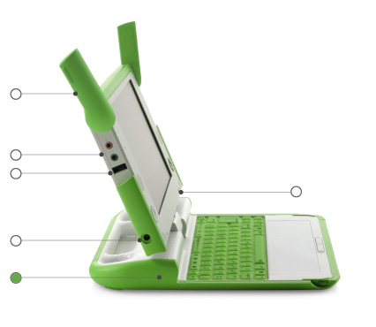Rechargeable battery
Since many children in the developing world live “off the grid” (in places with poor or non-existent power infrastructure), the XO laptop is designed to be extremely power efficient.
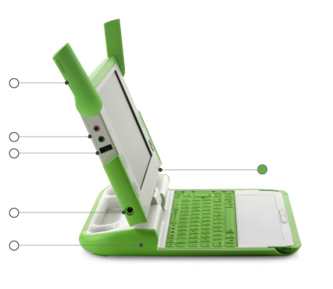
SD memory-card slot
There is a slot underneath the display that accepts SD memory cards for photos, video, and other content. Rotate the display so that the left-hand edge is over the keyboard—the slot will be accessible from below.
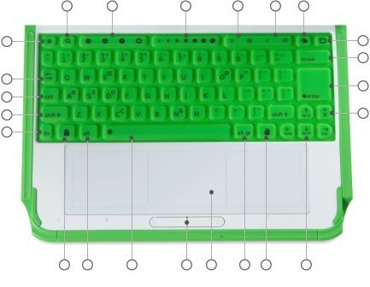
The keyboard and touchpad
The keyboard and touchpad—which are dust and water resistant—has some special keys for additional functionality. See the wiki for a complete list of keyboard shortcuts. Please see laptop features for an explanation of the other laptop buttons and controls. Note that we localize the keyboard for each country to the primary languages of that country, so your keyboard may not be an exact match the one in this figure. (Mouse over the circles in the figure above for more detailed information about the keyboard.)
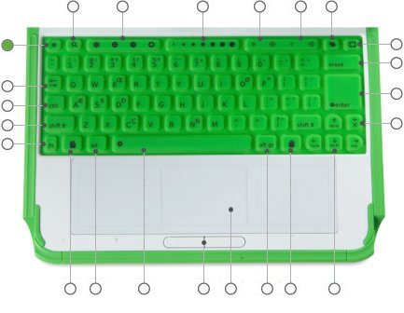
Escape key
The escape key is labeled with a white × symbol on a black circle. The escape key is most commonly used in combination with the control key to quit activities (Ctrl-Esc).
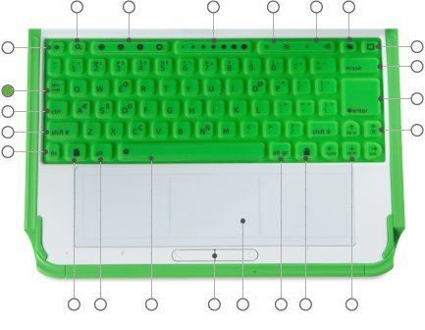
Tab key
The tab key is labeled with arrows pointing right and left. The tab key—in addition to its standard use—is used in combination with control and shift to cycle through open activities (Ctrl-Tab cycles forward through running activities).
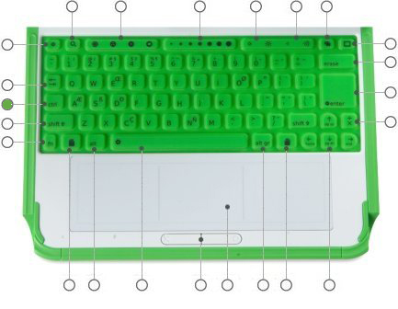
Control key
The control key is used in combination with other keys to issue commands (e.g., Ctrl-c is used to copy to the clipboard; Ctrl-v is used to paste from the clipboard).

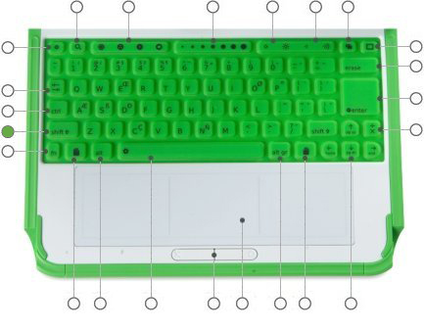
Shift key
The shift key is used in combination with other keys as a modifier, most commonly to shift between lowercase and uppercase in Latin-based alphabets.
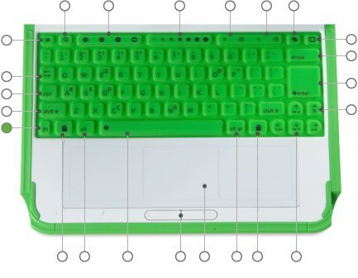
Fn key
The function key is used in combination with other keys as a modifier (e.g., Fn-erase is delete; Fn-up arrow is page up).

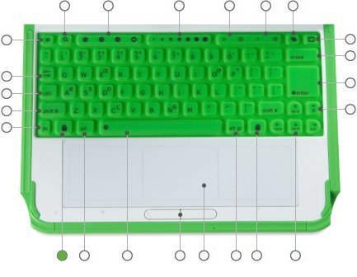
Grab keys
The grab keys are reserved for a future feature.

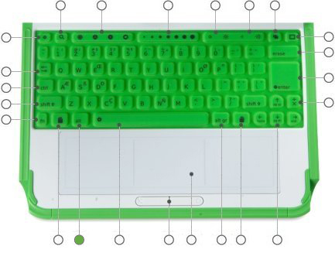
Alt key
The alt key is used in combination with other keys to issue commands (e.g., Alt-enter toggles full-screen mode; Alt-space toggles the tray visibility (works in Browse but not in Record).
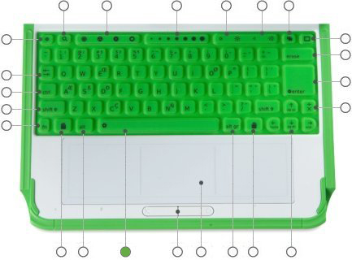
Spacebar
The space key, when used in conjunction with the function key (Fn) invokes the system “view source” function in enabled activities.
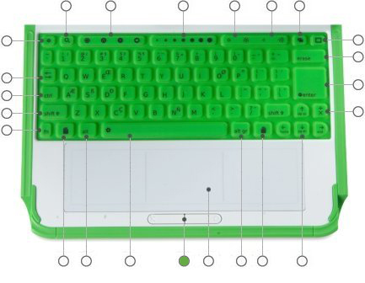
Touchpad buttons
There are two touchpad buttons: one labeled with a × and the other with a circle. Whenever you are asked to “click”, you should tap the left-hand button (×) once. In the future, the right-hand button (o) will be used to bring up hover menus instantly. (We've tried to eliminate the need to “double click” throughout the interface.)
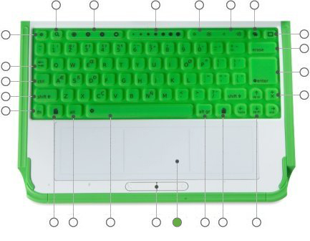
Touchpad
The XO has a dual-mode touchpad. The center portion is capacitive: it used to move the cursor as you move your finger. The entire surface is also resistive: in the future, activities can be used with a stylus.
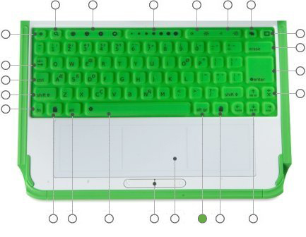
Alt Gr key
The alt graphics key is used in combination with other keys as a modifier, most commonly to select an alternative letter or generate an accented character. The details of this functionality varies from keyboard layout to keyboard layout: for example, on the US keyboard, AltGr-J generates a € (euro sign); typing the character “a” followed by AltGr-4 generates á.
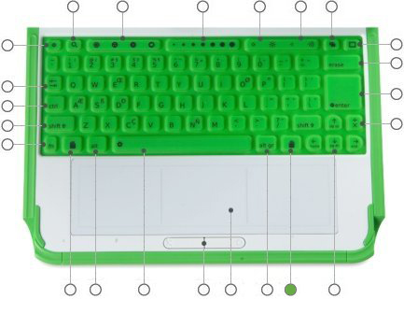
Grab keys
The grab keys are reserved for a future feature.

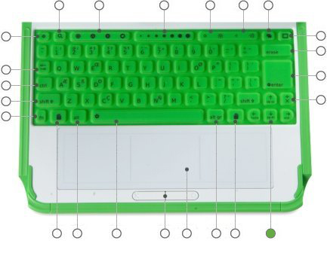
Arrow keys
The arrow keys are used for navigation; combined with the function key (Fn), they are used for page up, page down, home, and end.
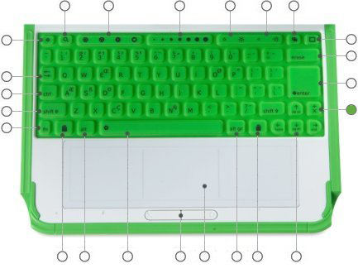
Language key
The language key is found on keyboards layouts that combine Latin and non-Latin scripts. It toggles between scripts, so, for example, one can switch between typing in English and Hindi with a single keystroke. (On Latin-only keyboards, the language key has been replaced by a × and ÷ key.)
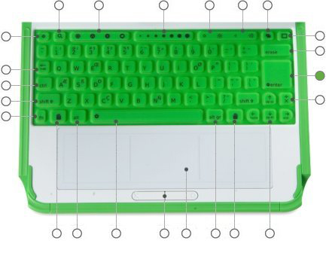
Enter key
The enter key—in addition to its standard use—is used in combination with modifier keys (e.g., Alt-enter toggles full-screen mode).
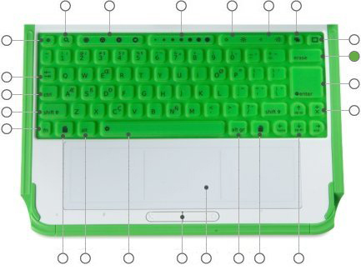
Erase key
The erase key deletes the character behind the cursor (backspace). Fn-erase deletes the key under the cursor (delete)
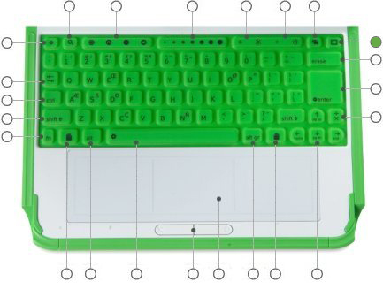
Frame key
The frame key toggles the presence of the Frame on the screen. (The Frame is the black border around the screen that holds the activity taskbar, clipboard, buddy list, etc.)
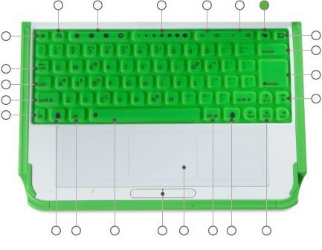
Bulletin board key
The bulletin board key is reserved for a future feature.
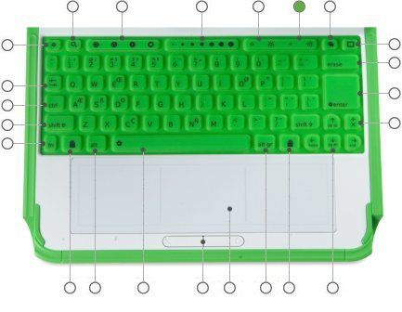
Volume controls
The volume keys lower and raise the audio level.
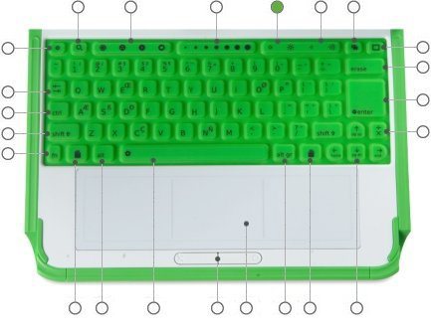
Brightness controls
The brightness keys lower and raise the brightness of the screen backlight. (To turn the backlight off completely may take 4–5 button presses.)
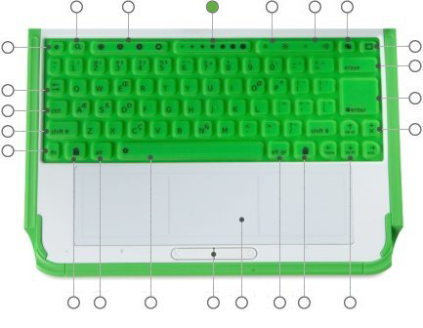
Programmable slider
The slider keys are reserved for a future feature.
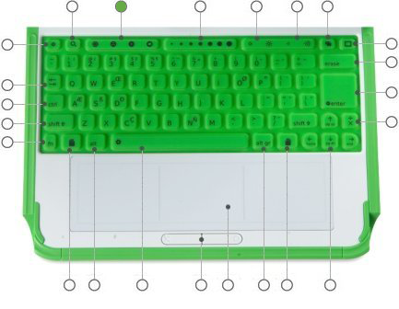
View keys
The four view keys, from left to right, take you to the Neighborhood view, the Group view, the Home view, and the Activity view.
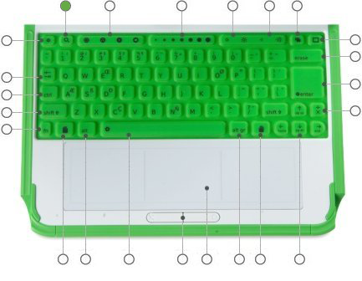
Search key
The search key takes you directly to the Journal.
The battery
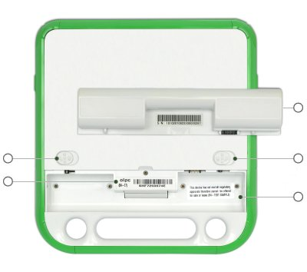
The XO can be hand charged via a crank, pedal or pull-cord—or recharged by a directly connected solar panel. (Mouse over the circles in the figure above for more detailed information about the XO battery.)
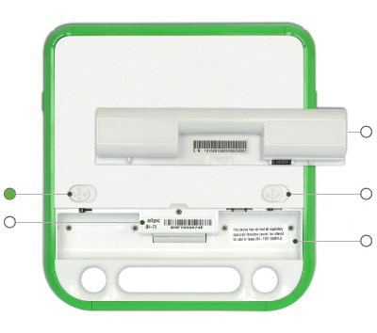
Battery latch
Two latches hold the battery in place. The open position is towards the outside edge of the laptop. The right-hand latch is spring-loaded; it must be held open during battery insertion and removal. The left-hand latch should be slid into the lock position after battery insertion.
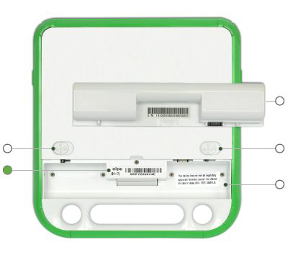
Model No. and Serial No.
The model number and serial number are on the sticker in the battery compartment. Safety certifications are also found there.
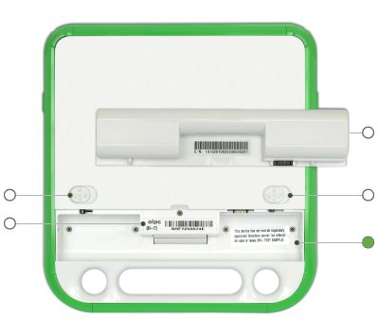
Inserting the battery
The battery is inserted into the battery compartment by putting the rounded edge into the compartment first, on the side nearest the handle. The latches should be pulled outward as the battery is inserted; as final step, push the latches inward.
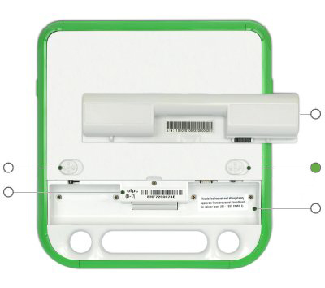
Battery latch
Two latches hold the battery in place. The open position is towards the outside edge of the laptop. The right-hand latch is spring-loaded; it must be held open during battery insertion and removal. The left-hand latch should be slid into the lock position after battery insertion.
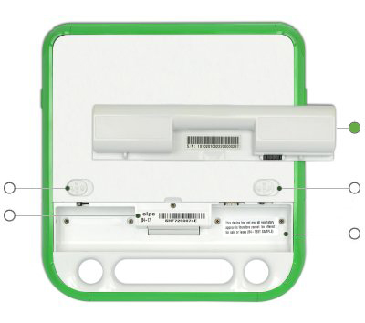
Battery
The XO battery operates for up to 2,000 recharge cycles (four times the lifetime of a typical laptop battery). It is extremely efficient and contain no toxic heavy metals.

