KAGUGU NEWSPAPER.
30 / 07 /2009
ubarinde kwigunga dufasha nabatisho
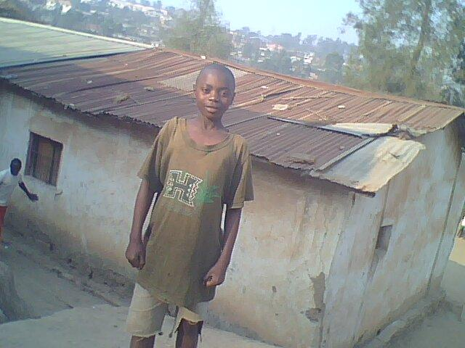
bose bose twishim ane nabo kugirango

batigunga ahubwo bahore bishimye
Uyumwana yabuze ababyeyi acyiri muto none aba mu kigo cya Rwandarwejo

afite umugambi wo kwiga ashyizeho umwete kugirango azibesheho
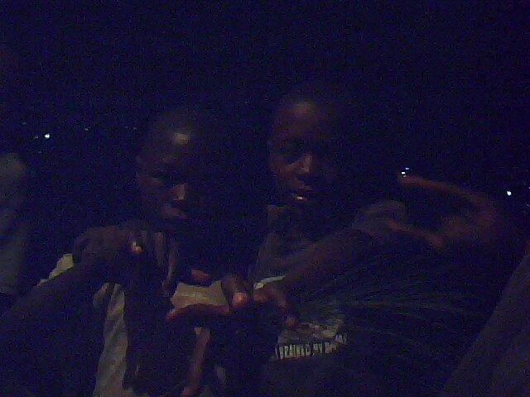
amajije gukura.

ITE K'UMWANA WESE NK'UWAWE
(Treat to every child as your own)

NSABIMANA,NKURUNZIZA,MUNYANEZA na NSENGIYUNVA

Aba bana nabomu murenge wa mwili mukarere ka KAYONZA. bose bari inshuti bigana mumwaka wa gatanu (5), muri primary ya mwiri, kandi bose bari inshuti. Babonye ibyo kwiga bibananiye, bajya inama yo kujya i kigali. Umva yemwe nabo ngo bigiriye inama yo kujya gukorera amafaranga.

Ubwo abashinzwe icyo kigo babashyira mumyuga bariga bararangiza non'ubu bafite akazi(imirimo).None biteje imbere yemwe baratunze baratunganirwa.Ubu bakaba bakangurira abana baba mu muhanda ko bavamo bakajya kwiga imyuga yabateza imbere kandi bakabashishikariza kwibumbira mu mashyirahamwe nabo ejo bakigirira akamaro, bityo bagatera imbere.Kandi bakaba bashishikariza ababyeyi kujya bita kubana babo bakajya babakurikiranirahafi.

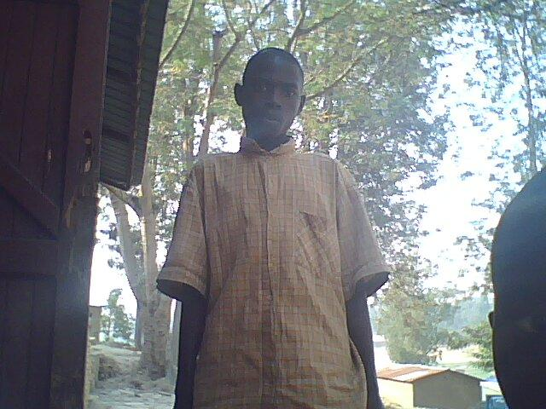
PHOTO by NKURIKIYIMANA Gablier KAGUGU Primary School. KARIMU na KALISA ni abana bava inda imwe kuri se na nyina

KARIMU afite imyaka16, KARISA ni14,aba bana bari bafite ababyeyi bose ariko ababyeyi baje gupfa bazize icyorezo cya SIDA abo babyeyi bakimara kwitaba Imana
basigara aho bonyine. Ubwo abo bana bari bafite se wabo i Kigali ubwo abagirira
impuhwe arabazana ngo abarere hamwe nabe ba 3 koko arabazana ,yemwe ngo bagere kwa se wabo i Kigali ,nyamugore
wa se wabo ntiyabyishimira ubwo abana ntibabayeho neza ubwo nyamugore
akajya abatekesha burimunsi ntibabone uko boga bakoga ku cyumweru gusa ,ntabwo bajyaga ku ishuri nkabandi bana nyamugore akajya abatuka ngo ni abanebwe ,ni ibisambo hashize iminsi abana babonye ko babayeho nabi bajya umugambi umwe wo gutoroka ngo bigendere.
ubwo bazindu kare nkuko bisanzwebigenda bafata utwenda twabo mugakapu.
bagenda nta munttu n'umwe murugo ubizi arinyamugore na se wabo
ntanumwe wari ubizi kuko abana batari bazi aho bajya.
biriwe bazenguruka mu mihanda y'i Kigali bugorobye POLICE irabafata ibaraza muri gereza nkuru ya Kigali iri ku Muhima bamaze ukwezi kose muri gereza .
Opeji arabafungura aba POLICE babajyana mukigo cy'imfubyi.
bahabonera ubuzimabwiza bifuzaga.
naho iyonkuru yabo bana yasubikiwe.

KAGUGU NEWSPAPER
Bana dukunde ishuli kuko ari ingirakamaro.
Uyu mwana yavuye m'umuhanda a jya mw'ishuri none ubu ariga.
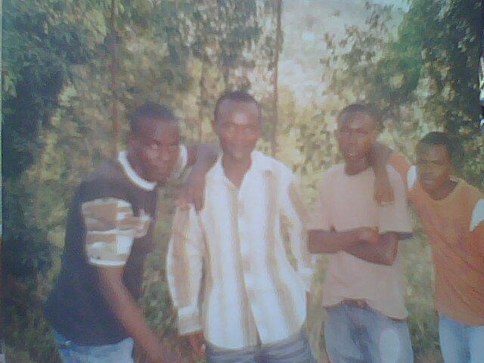
PHOTO by NKURIKIMANA GABRIEL KAGUGU PRIMARY

nzakunda kwiga kuko ari ingirakamaro bana rubyiruko dufata
nyije kwiga tugire inama bagenzi bacu
ko ishuri ari ingirakamaro.
nitwumva inama tugakurikiza ibyotwumva tuzamenya
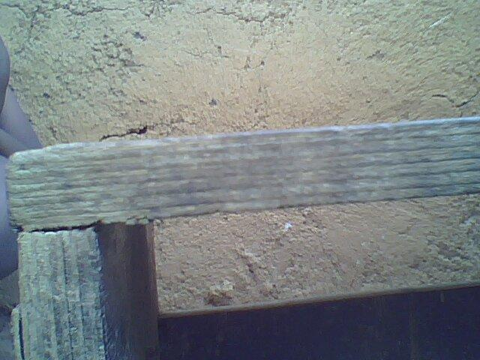
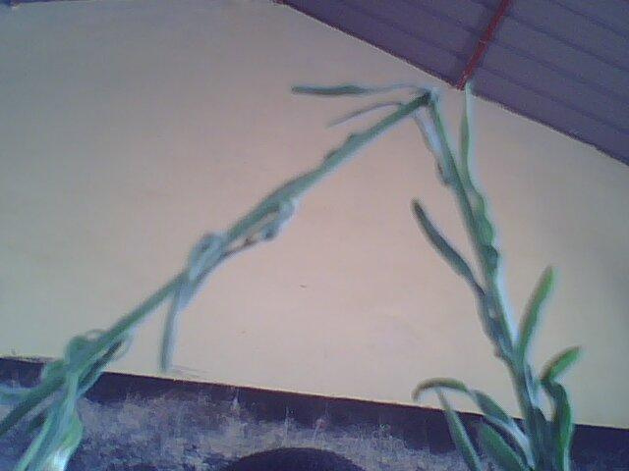
KURI TARIKI YA 30/07/2009
UBUNGABUNE IBINDUKIKIJE
nagerageje kubaza beci babwira bati''ibidukikije biduha byinshi byiza
URUNG:igiti,amazi
igiti iyo gitemwe ntamumaro gitanga
NB;murasabwa gutera ibiti
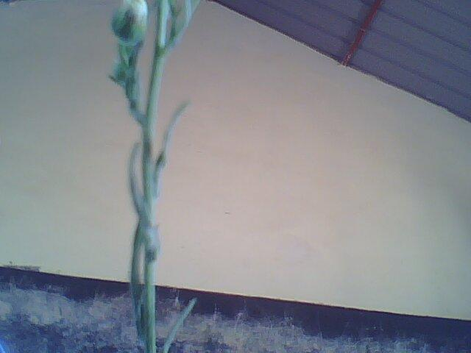
INGARUKA ZO GUTEMA IBITI
ntango imvura iboneka kandi ahari ibiti hakaba ubutayu izuba rikaba ryinshi
imyaka ikarumba
ICYO TWAKORA KUGIRANGO IBITI BITAG-
AbaNYUKA
nutema kimwe utere ibidi
igiti nikiza Pe

_________________________________
AMAZI
amazi nimeza iyo ataduye tugomba kyabuga rero kugirango atungirire akamaro
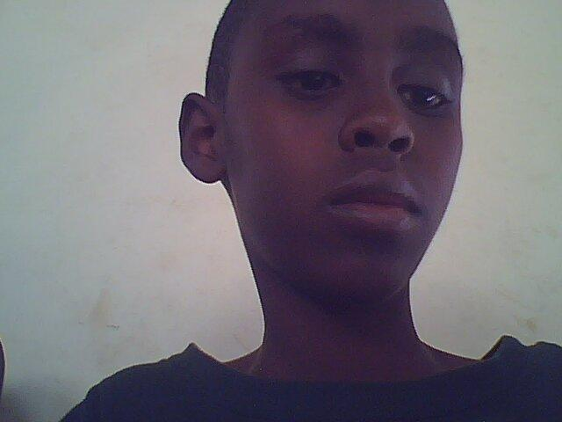
name;Manzi olivier
photo
Nyiri kwandika ino
mvaho
Class;p6b group d
age;12
murakoze murabeho

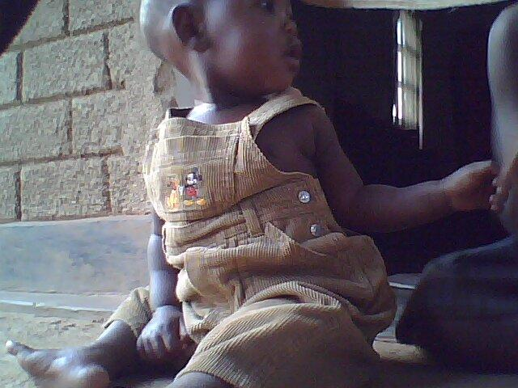
my name is ishimwe vives of kagugu I am nine years old in p.3. Forcing children to do what they aren’t ready to do is a habit that I donot like this is because I feel they are violating childrens rights, as
children, we have the right to be freely taken careof.
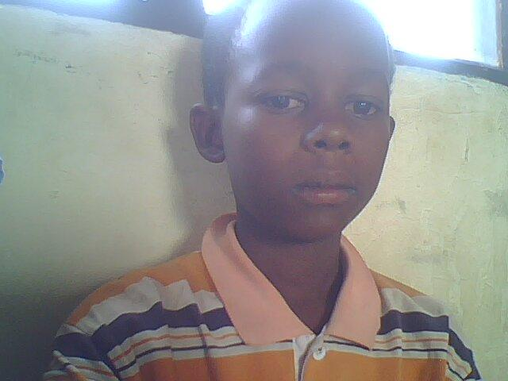

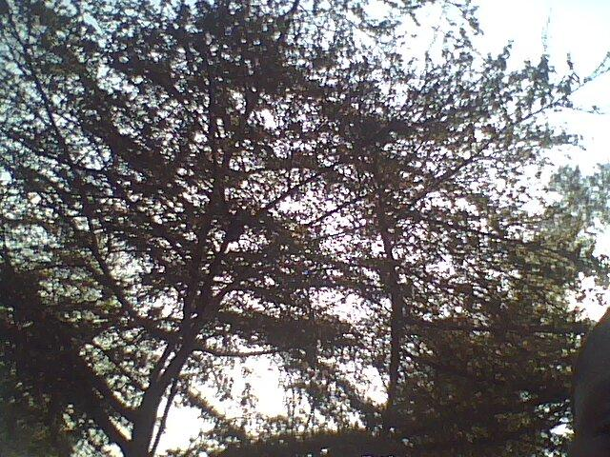
TUBUNGABUNGE UBUZIMA BW 'IBIDUKIKIJE
tubungabunge ishyamba N'inyamaswa Ziba mumashyamba ,Ishyamba niryo riduha imvura akayaga keza ririnda ,isuri none .akaba,ariyo mpavu nkangurira abaturarwanda bose
kwita ,kubidukikije dutera amashyamba dufataneza ayodufite twirinda barutwitsi dutema igiti dutera bibiri akaba ariyo mpamvu nkangurira abarezi natwebarera Ababyeyi bacu Nabayobozi .batuyobora .bitekubidukikije,kandi,bashi shi karize.abatura,rwanda,gutera.Ibiti .yari.UMUTANGAZ ,,, AMAKURU,,WANYU,ARIWE,UFITABE EMMANUER IMVAHO NSHYA;;

