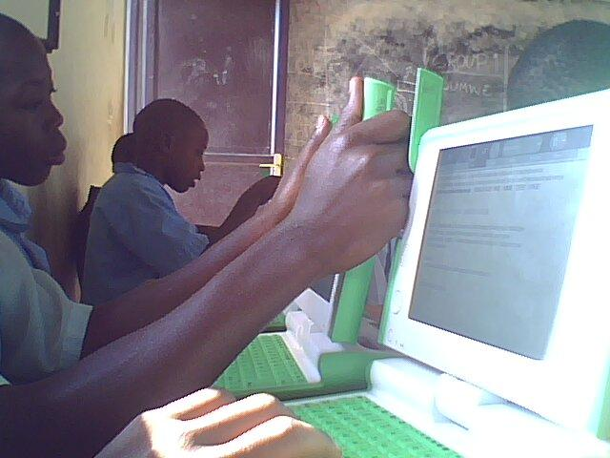
byanditse ku30/7/2009
ikigari kizarangira ku 17/8/2010
P.4 Newspaper

Gutaka Kagugu
Bynditswe:buging
kagugu nziza reka tukurate wahebuje amahanga yose kubera iterambere ufite kandi rirabye''abarezi bawe hamwe n'abanyeshuri bawe bose barangwa n'ikinyabupfura,ubwitonzi hamwe n'ubuhanga ''

bugingo;Rurengera;nshimyumukiza;NIBISHIMIRWE;HAKUZIMANA;niyonzima. IMVAHO NSHYA mu icapiro bya kagugu B.P kirirwanda
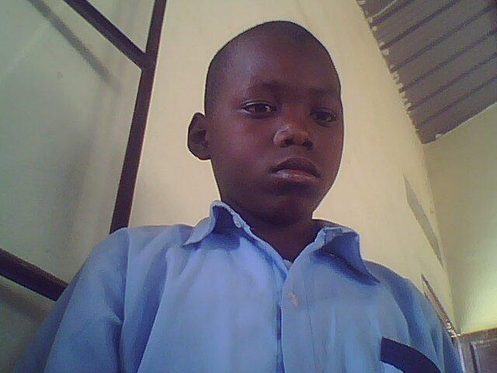

______________________________________________________________________________
Imvaho nshyatarikiya28-30nyakanga Amateka urup
KuMwaka32BruceLee yapfuye AK oze amateka
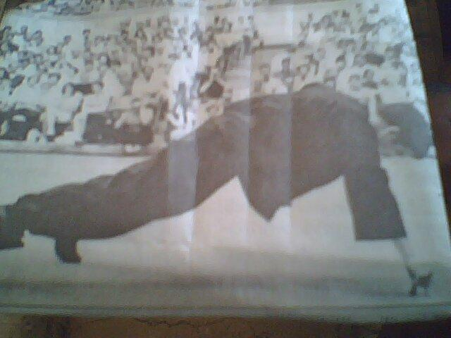
NshyutibakuzibaBruce Leeharimo urubyirukorwashimi Nshyaganafirimezeyariyarahimye nibyoyakoragabyaraba

Ashiminshyagan,abyo ayamafoto arumwanawayabonye
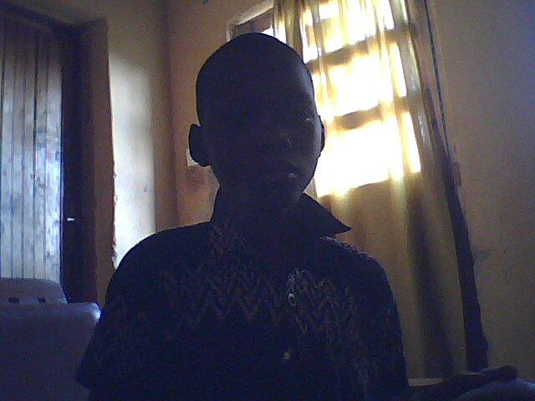
Aravuga ati:<iBruce abayaramubonyekibayarishimyecy
Anecyane >uwomwanayongeyekuvuga ati:<nkunda na mafoTO ahora ayarota > BruceLee amazekubura ubushobozi atangirakwikore

kugiticyeYiyandikiraga,,script,,yafilimi.akaba umukinyi nnyiwafilimi ukomeyendetse akayiyobora. Ibyonanibyo yakomejemurifilimi, WAyofthedrgon,,mu1960yarayandiste arayiyoborandeste anayikinamo anarayiyobo ra BruceLee ahimmba indifirimi iryoshekurusha
izindifilimiyakinaga. hasize amezi abiri ahimba ifiimi itwara amadorari200.
hasize icumweru ahita apfayapfuye azizeko ari umurusiya tariki y,a10gicurasi1963
Bruce Lee ahimba indifilimiyoyari iryoshekurusha izindifilimiyakinaga

HASIZE amezi Abiri ahimbafilimi itwara amadora200
tarikiya10gicurasi1963
HAKUZIMANA EMANWEL
YIGA KAGUGU P4eE
GOUP : A
MARINSI BRUCELEEYAPFUYE N.75@-hoo.com

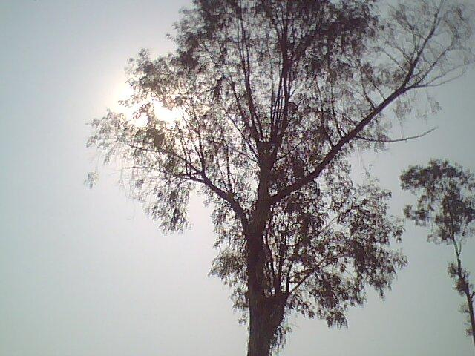
______________________________________________________________________________
IMVAHO NSHYA

L30/7/2009
KUBUNGABUNGAIBIDUKIKIJE

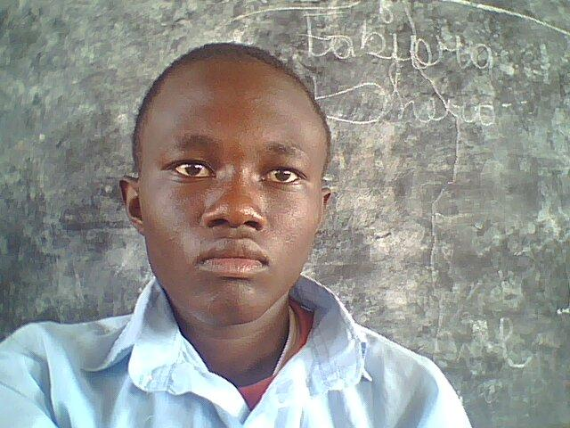
Banyarwanda banyarwanda kazi turagirango Turwanye barutwitsi abantu bajya batwika amashyamba nka Gishwati Nyungwe ;abantu batwika amakara ;bakuramo imbaho cyangwa abahakura mu mashyambaUrugero nka park Ibirunga;umuntu yagiye guhakura muri park arahatwika;igikorwa cyo kuzimya uwo muriro kuwuzimya bikaba byaratwaye akayabo k'amafaranga yu Rwanda akabakaba miriyoni 50frw yu Rwanda;kandi ayo mafanga akaba yari kugirira imfubyi zazize genocide ;nabandi batishoboye.

JULY 30 2009
P5 NEWSPAPER

31/7/2009
Byari ngombwa kotwi
Bohoza
Abayobozi byaringombwa KOtwakwibohoza tariki ya,15 Nonerero natw turaca ingenga bitkerezo
Mbi yagenosideibyo nabyo Abayoozi babidufashamo
yari patrick
TURASHIMIRA RETA YACU
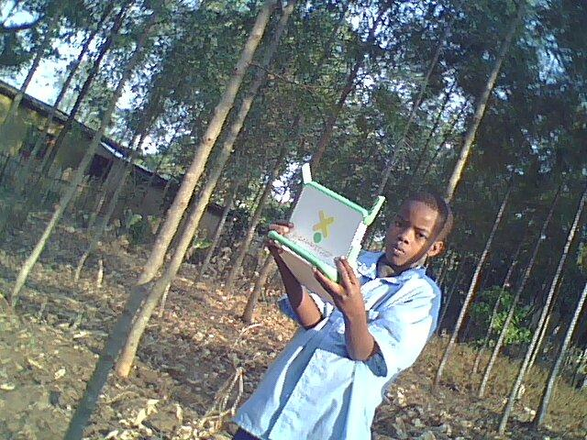
Iterambere rya kagugu
P4newspaper

Twagiranye ikiganiro n,aba nyeshuri ba kagugu guhera
mu wakane kugeza muwaga tanu kubyerekeranye na mu

dasobwa batubwiye ko bata kigana amakayi basigayebigira kuri mudasobwa batubwi yeKo ibi babikesha peresident ware puburika y,urwanda ko
ariwe wabagejejeho ibi byo se none natwe turashimira
peresident warepuburika y,u rwanda ko iyinkunga koyaza
teranabandi bana yari nyandwi.

