XO Time - week 2 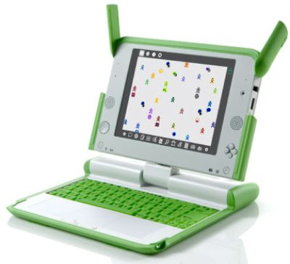


XO Kazubwenge
Hello to all my new friends!
I am so happy to receive your projects in Turtle Art! Next week I am going to share some of them with you.
If you didn’t read my letter last week, about shapes, you can find it at http://wiki.laptop.org/go/XO_Time

I am so excited with the shapes you created that I was wondering if is also possible to teach the Turtle to draw a house using Turtle Art. Do you know how to do it? Can you show me how your Turtle Art house looks? Are you able to do a script to draw a house?
Remember, to do the script you drag and drop the commands to screen and connect them. To see what happens, just click on the scripts. To erase your drawing, click on erase.
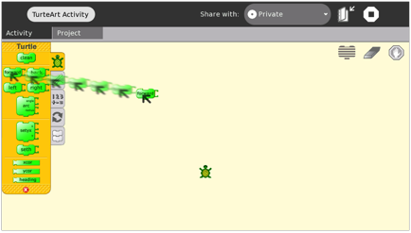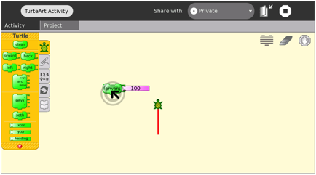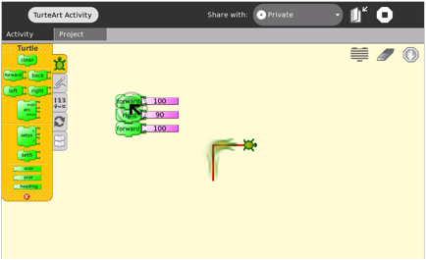
Here are the scripts that I used to teach the Turtle to draw a square, a circle and a triangle:
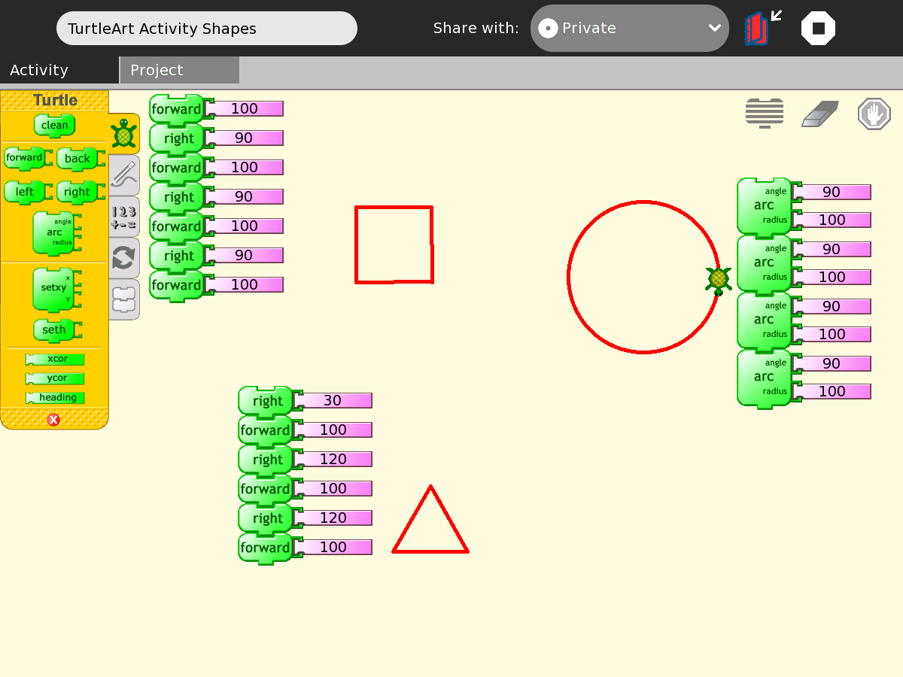
Script to draw a square.
Script to draw a circle.
Script to draw a Triangle.
I have an idea! Try to use the change the colors of your house so it is not just red, like the color of my shapes.

Use the “pen” option to change your colors.
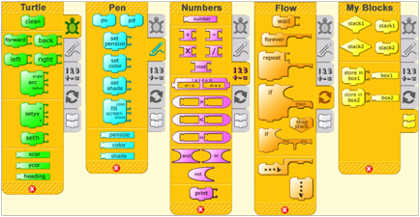

Change pen size, color & shade here. Try to change the numbers around
DOUBLE CLICK over the script to execute

To send me in your work:
Once you are done, save your work, by pressing “keep.” This will save your project to the journal. Once you have saved, click on your journal. You should see your project as the most recent on the list. It should be called “turtle art activity” click on this writing and change the name to your name.
Then find a location with Internet access and log onto your email. Open a new message and click “attach file” or “attachment,” etc. You should look for your project. Double click on your project, so that it is attached to your email. Write anything in the message that you want me to know about you. For example, how old are you? What grade are you in? Which school do you study? Once you are done, send your email to: xo@laptop.org
YOU CAN FIND HELP WITH MY FRIENDS FROM OLPC
SATURDAY, JULY 11, 1:00-3:00pm AT MTN CENTER AT BOURBON CAFÉ (just look for people with XOs)
Bring your XO!!!

