Social School Mapping Project
April 18-25, 2011 Kigali, Rwanda

- Social School Mapping Project attendees
- OLPC-Rwanda/Rwanda Program Staff
- Social School Mapping Project Overview
- Goals
- How we came up with this topic
- Challenges
- Successes
- Ways it can be replicated
- Lessons Learned
- Plans Moving Forwards

I. Social School Mapping Project attendees
This project attended by 32 students of P6A class, and two teachers from EPAK.
II. OLPC-Rwanda Staff
Julia Reynolds, Learning Field & Development Coordinator, Project Coordinator/ Documentation, julia@laptop.org
Desire Rwagaju, Learning Development Officer, Conductor of project, desire@laptop.org
Jean Claude Tuyishimire, Learning Development Facilitator, Lead group work.

III. Project Overview
The social school mapping project aimed to improve children’s mathematical knowledge by creating projects through a social and mathematical mapping of their peers, school and community. Through the implementation process of this project, we observed EPAK children using skills such as harnessing their creativity, managing their time and integrating mathematical processes through the use of statistics. They started by brain storming meaningful questions they could use for their survey using a broad variety of Activities such as Etoys and Paint. They concluded by using the questions they brainstormed to survey their class, and the community and consolidated their data using Poll Builder activity.
Each single activity of the project has been done in an engaging and funny way to give a good learning environment to both students and teachers.
IV.GOALS
Students should:
- Practice use of advanced math;
- Learn to work in teams, sharing ideas, develop listening skills and coming to collective group decisions
- Use their laptops in advanced ways in order to create a social goal of mapping their class, school, community
- Develop their own survey questions, pushing them to think creatively, students will also have to collective deice how to collect and measure results, again using advanced mathematical procedures, but also thinking critically and solving problems
- Teach other students, creating an important school dynamics, the walls of the schools will also be “broken” as different grades will work together on the same project and parents and the larger community will be included.
- Create an ongoing demographic club

V. Process Overview:
The project was implemented during school time trying to integrate the activity as a new classroom strategy. That way children were enabled to discuss, learn and work collaboratively. The participants were introduced to example statistics in terms of percentages and ratios from which they can derive ideas and survey questions. As part of the data fieldwork children of P6B were chosen as the target population and the children of P6A were in charge of create and apply their survey questions. The answers for those surveys were recorded and statistically analyzed in groups. The participants have also been provided with time to think about their ideas, plan their surveys, and continue the work at home. The home works enabled students to think deeply on an important statistical question that will tell a lot about the class. Finally the results were interpreted and presented using Poll-builder activity. The results have been shared around the school to raise new questions for an ongoing school mapping activity.
VI. How we came up with this topic: Mathematics is a subject with a reputation of being difficult. In the Rwandan education context, mathematics has been described as subjects for geniuses. This could explain the lack of creativity in teaching this subject. In this order of ideas it’s possible to think that teachers could see it as a very difficult task to create a mathematical project around the use of laptops. This project is closely tied with the Rwandan curriculum since students work with percentages, graphing, statistics and data analysis, all skills that can be found in NCDC’s mathematic curriculum outline for P6 students. In addition, students can work together in teams and learn more about themselves and their community, which is also outlined in NCDC’s social studies curriculum. Lastly, students have to think critically, be creative and solve problems. All of these criteria make Social School Mapping Project overarching NCDC’s goal, which is to create a generation ready to compete in a knowledge-based economy.

VII.CHALLENGES:
Level of Math
When the teachers assisting in the class were first explained the goals of the project, they complained that the level of math would be too easy for the students of P6, but, when students were asked to create percentages and fractions they could not. Because of this we had to alter our agenda to support the development of these skills. The outcome of this turned into one of the more successful outcomes of the project which are described in detail in the below "successes" section and "concretization of knowledge."
Group Work
This project was being done at the school, during school-time, with the regular teacher of the class plus the OLPC Champion teacher present. This created the condition for working in a more formal learning environment, which we found impeded the ability and space for students to work in groups. Eventually when students managed to work in groups it had a great impact on students collaboration to generate distinctive survey questions and teach each other how to use Poll-builder activity as well as different method of conducting surveys.
Time
The allotted class period was very short--just 40 minutes on Monday, Wednesdays, and Fridays. After addressing the lack of basic math skills we had to extend the project an additional week in order to conclude. Limited number of teachers participated because of the end of the term work.

Involvement of teachers
For this project two teachers were involved, the regular P6 teacher and the OLPC Champion teacher. While they were both physically present for a portion of the project they did not engage in a meaningful way. The majority of their time was spent on class discipline which, at points, would impede the student's comfort and creativity levels. Their contribution was mostly noticed in group work guidance and survey question choice. This shows the necessity of previous training of teachers to know how to behave and engage kids in these kind of activities.
VII.SUCCESS
Students practiced the use of advanced math, learned to work in teams, shared ideas, developed listening skills and came to collective group decisions. Students figured out laptop use in advanced ways in order to create a presentation of their work to socially map their class, school and community.

Creativity and critical thinking:
Our main focus was to develop student’s creativity, to achieve this, we proposed that, in partners, they create their own statistics company, think of the most important survey question they can, collect and present the results in the best way. This led to great outcomes, such as the projects below:
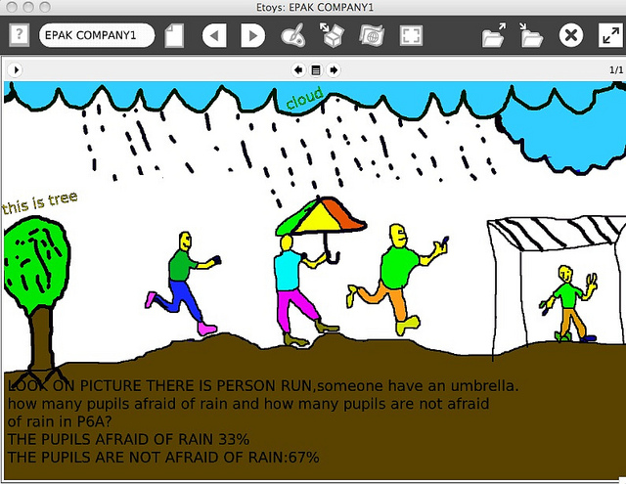
Social Mapping Project by Mustafa

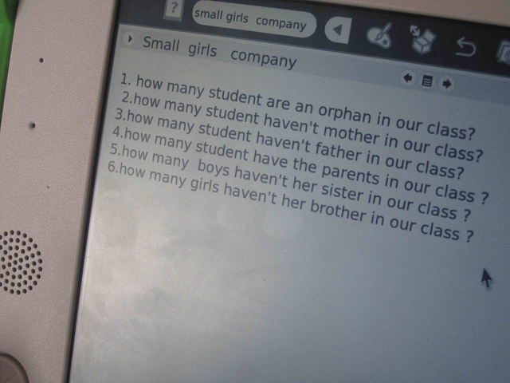
Kids developed questions demographically related to EPAK community in details, before starting the survey.
Students developed their own survey questions, this pushed them to think creatively. They have had also to collect and measure results, again using advanced mathematical procedures, but also thinking critically and solving problems
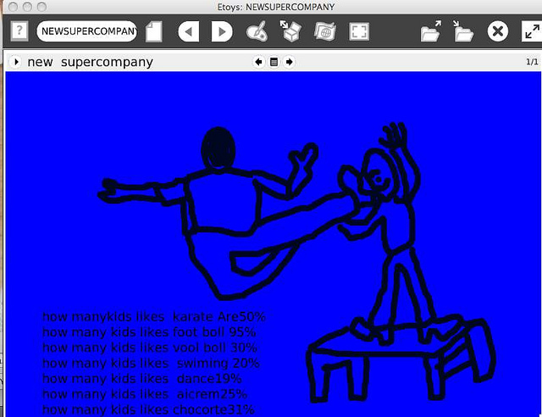

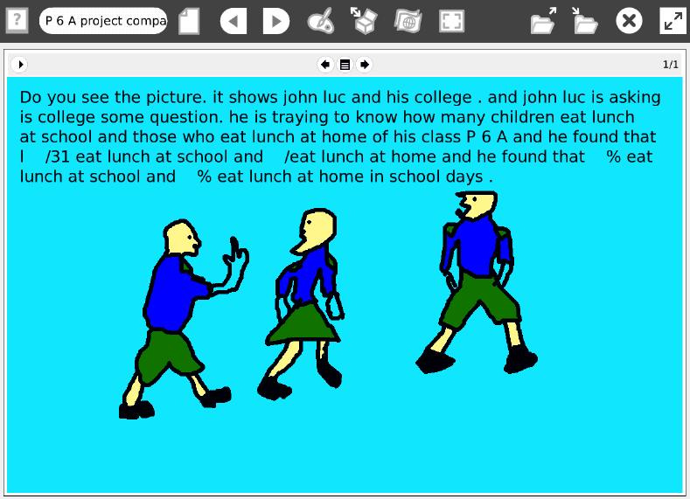

Social Mapping Project by J. Luc
P6 EPAK student, J. Luc Nsabimana, asked his peers if they take lunch at school or at home.
As seen above, students decided to use animated drawings and paint to express their proposals.
Students taught other students, creating an important school dynamic. The walls of the school have also been “broken” as P6A and P6B classes worked together on the same project, while parents and the larger community have been included through responding to the survey questions.

Concretization of knowledge
Shortly after starting the project, we recognized that the students had a low level of math, despite the fact that the teachers told us it would be “to easy” for them. We found that they had forgotten or had not internalized what they were taught because they never did anything concrete with the knowledge. Through this project, we worked with them to ensure they developed these skills and used them to develop something concrete. We started by first drilling them on the right equation, or the “magical equation” to use to create ratios and percentages; after practice; students took polls to practice using questions about celebrities in which each student had to vote using their body. Once they were used to these mathematical processes, students polled their class, fellow class coming up with both a percentage and ratio representation. This understanding made the shift to using Poll Builder easy, and introduced them, for the first time, to graphing.

Support from school
While there was a lack of meaningful engagement, the OLPC Champion teacher was committed logistically to help the project run smoothly. At the beginning of the project students could not take their laptops home, so each week the laptops had to be charged then dispersed before each session. Towards the end of the project, in an effort to work with the community, we asked the Headmistress if students could take their laptops home--she agreed and students had their own laptops for the entirety of their two-week April holiday.

IX. Ways it can be replicated
The project is directly derived from National Curriculum, this provides it as an example of laptop application for deep teaching of curriculum related topics, not only math, but also other topics that can be developed by teachers themselves. With the effort of headmistress, some teachers willed to re-conduct this project as it is, or modify. This project will be also shared to other schools so it can be replicated across the country.

X. Lessons Learned:
It is important to talk to teachers before starting the project ,to introduce them to what will be done to ensure transfer of our ideas on ways to work with students using laptops. It is possible to provide a space for fun, and creativity in a actual classroom to enable students get involved in joyful way in the process of projects development. We noticed that students forgot statistic previously taught due to lack of deep thinking and working about these skills, after they developed projects was a perfect evaluating method to ensure a student’s deep level of internalizing the knowledge.

XI. Plans Moving Forwards: Based on the outcomes of this project it was clear that we have to create a local school community of children using their laptops in powerful ways with guidance. We proposed an ongoing demographic club that will be working, directed by teachers headed by champion teacher, collaboratively with OLPC Rwanda team, to ensure a continuous use of laptops for deep learning.
Since this class attended the followed Scratch workshop which provided them skills to express their idea with simple programming, it was an opportunity to start developing scratch animation, games,…to express their statistical findings.
The entire school will work collectively to put forth and complete statistical analysis of the classes, school and community. These skills can be used in the future, by the school’s leadership to continue mapping the social aspects of the students ‘s development. It is good for students to think of their own survey questions for the first part of the project, as this will help to develop their curiosity skills. The school could also consider future work with P6 or other students to track performance of the school. For example, the headmaster may create a group of students who excelled or really enjoyed this project to monthly or quarterly survey the students. It could include questions like, are students liking school? What do they think the school can improve? Are parents happy with their children’s homework? etc. Questions like these that would prove as important knowledge for the school in order to develop. The statistics groups can use this data to also track interesting curves and trends.

