LESSON PLAN
COLORS – Rebuild the mosaic
Gcompris

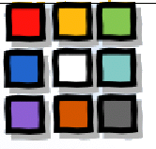
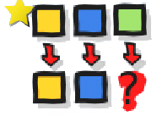
CLICK:

GOALS:
- To develop the visual discrimination for colors and observation skill

HOW TO PLAY: Click on the color down and click on the empty mosaic (right area) to rebuild the same mosaic.

