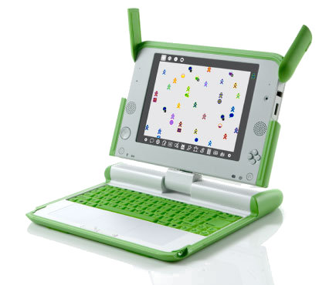

XO Kazubwenge
XO Time – week 16
Hello my Rwandese friends!


It was really nice to see how creative you all are. You did a great job changing backgrounds using Scratch. Let’s keep adding techniques ot make our stories even better. Today, let’s learn how to animate! Animation is a series of pictures that makes a Sprite, in this case, look like it is life-like.

First I will show you an example of animation using the STAGE. Let’s make it rain on our cat!
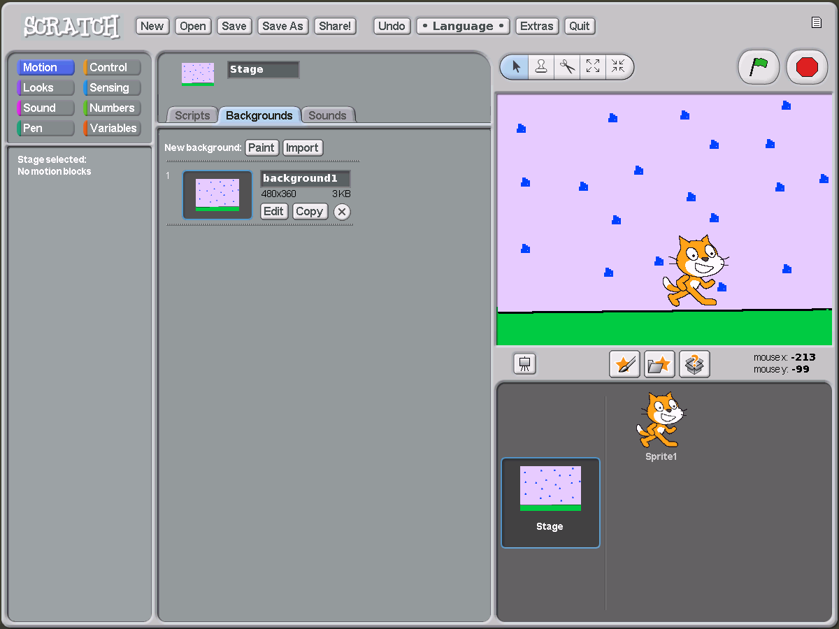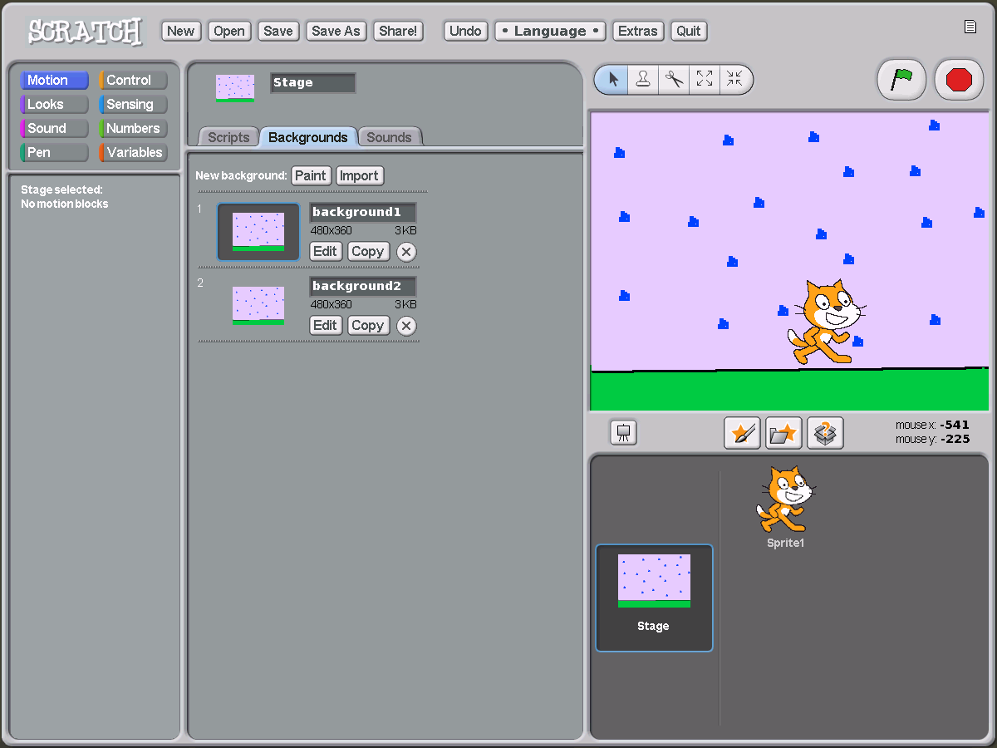
Remember, you can find all my letters to you here: http://wiki.laptop.org/go/XO_Time
Send your questions to: xo@laptop.org Read more information about Scratch: http://scratch.mit.edu

First, 1) I drew my background, by clicking on STAGE, then “backgrounds” then I clicked on edit and drew the rain
Second, 2) I click copy so now I have two identical backgrounds

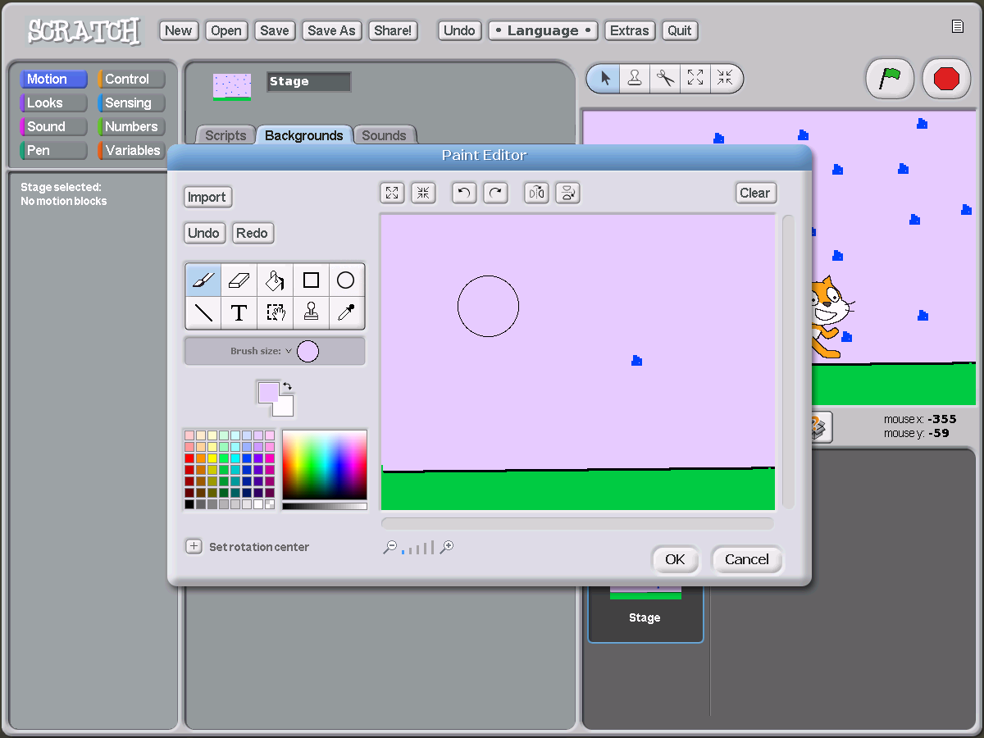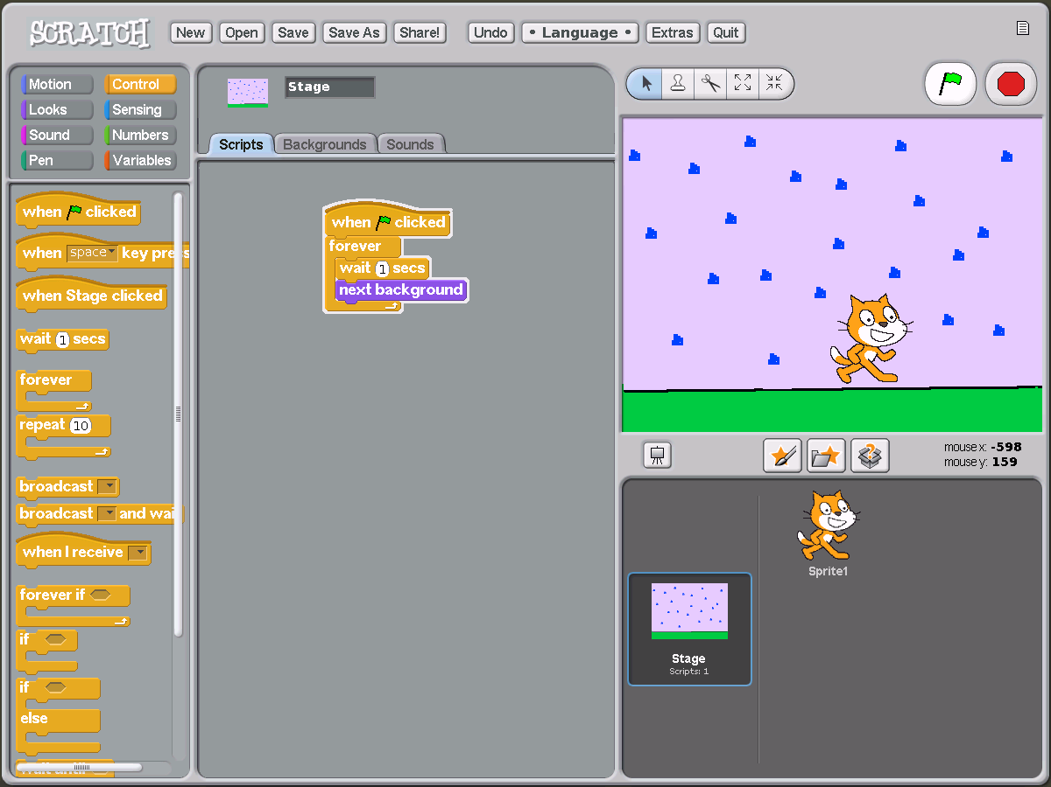
Third, 3) I click on “edit” of the new background and I erase the rain and re-draw it in different positions. Remember you can use the stamp  to paste the same drawing over and over
Fourth, 4) I click back onto “scripts” and I use these commands:
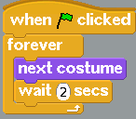 To make my sky look like it is really raining!
YOU CAN FIND HELP WITH MY FRIENDS FROM OLPC SATURDAY,OCTOBER 31, 2:00-4:00pm AT MTN CENTER AT BOURBON CAFÉ (just look for people with XOs) Bring your XO!!! THANK YOU BOURBON CAFÉ!!!!

You can also do the same thing with a Sprite.

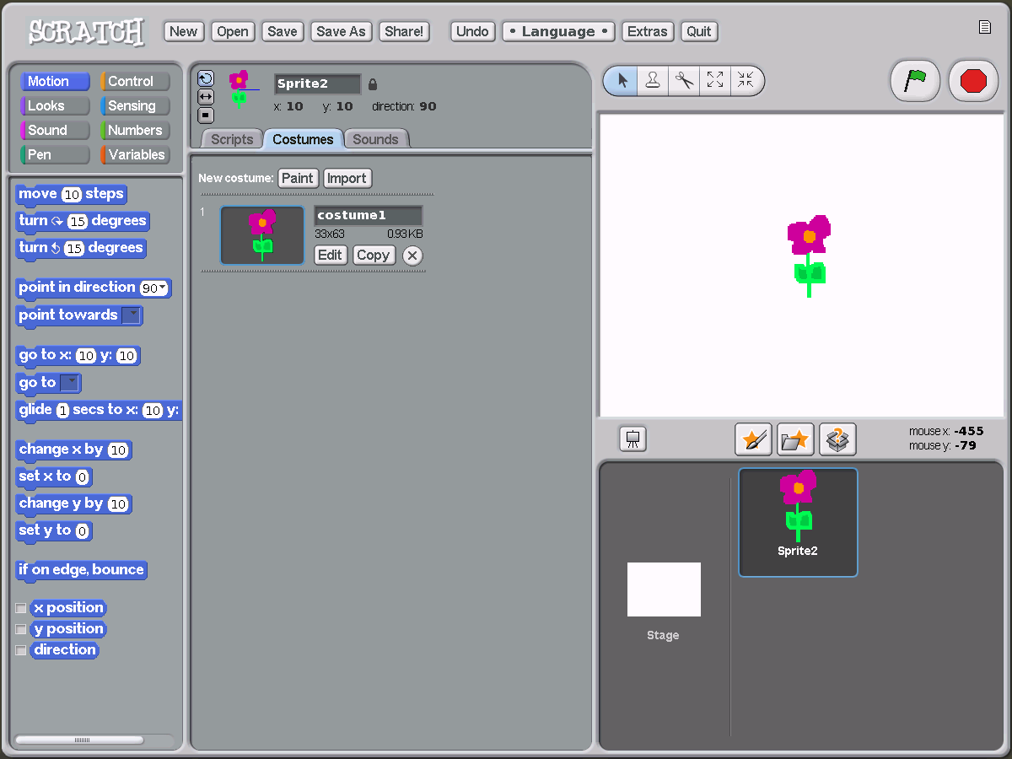
TO SEND YOUR WORK: If you are connected to the Internet, send your work, by pressing “Share!”. 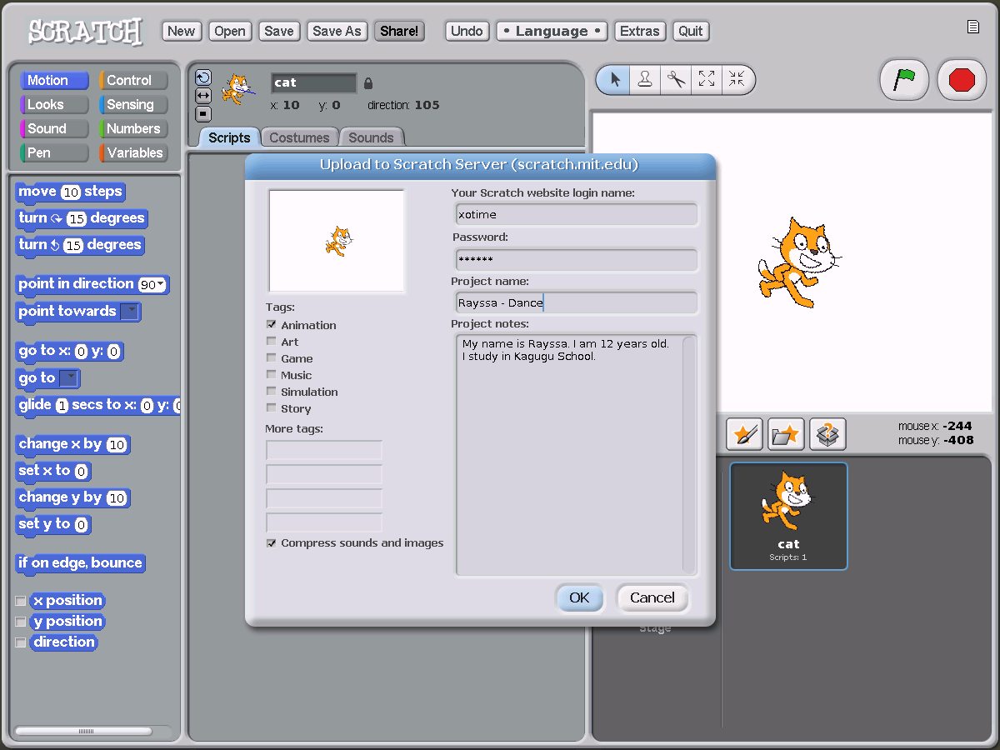
Once you press “share” just do the following:
My challenge for you this week is to create your own animation.
I draw my own Sprite. Then I copy it, and each time I add a little change to make the flower look like it is wilting.
Website login: xotime
Here, type your name and project name
Then write some info about you, your age, school, details about your project, anything! I just want to learn about you!
Then click ‘ok’
password: rwanda
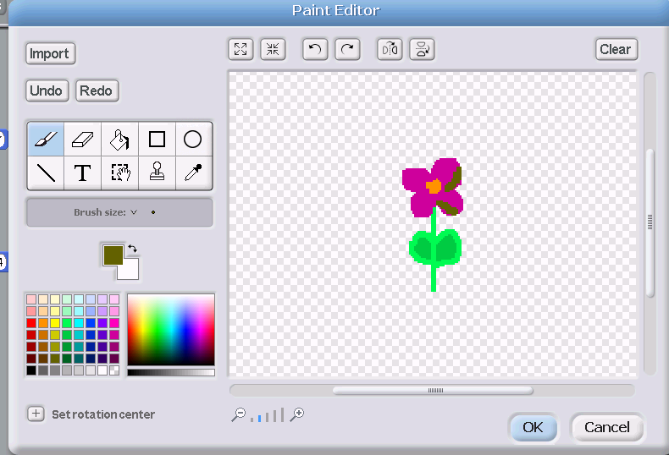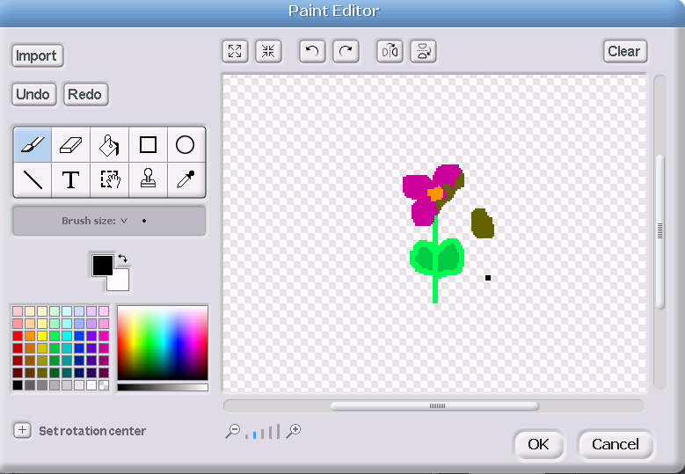
Then use this script and my flower looks like it is slowly wilting!

‘

