

LESSON PLAN

NUMBERS with dice

Gcompris



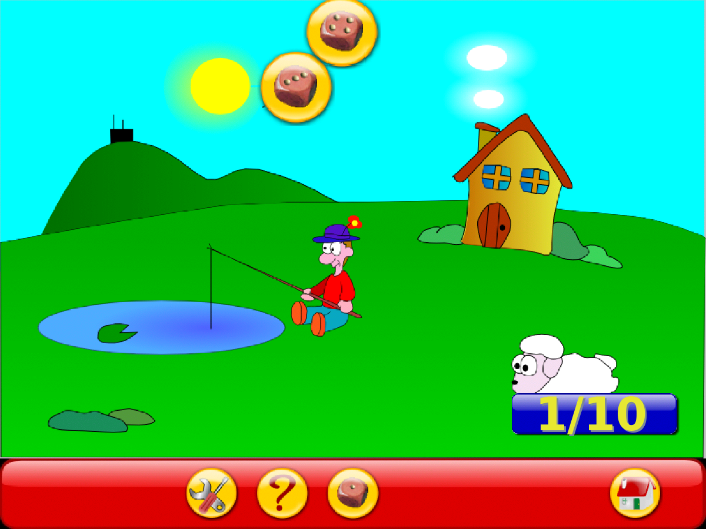

**How to play:** With the keyboard, type the number of dots you see on the falling dice.

**GOALS:**

* To develop counting skills
* To get familiar with numbers (visual representation, sound in English)
* To get familiar with laptop keyboard

Click to enable the sound

**CLICK:**