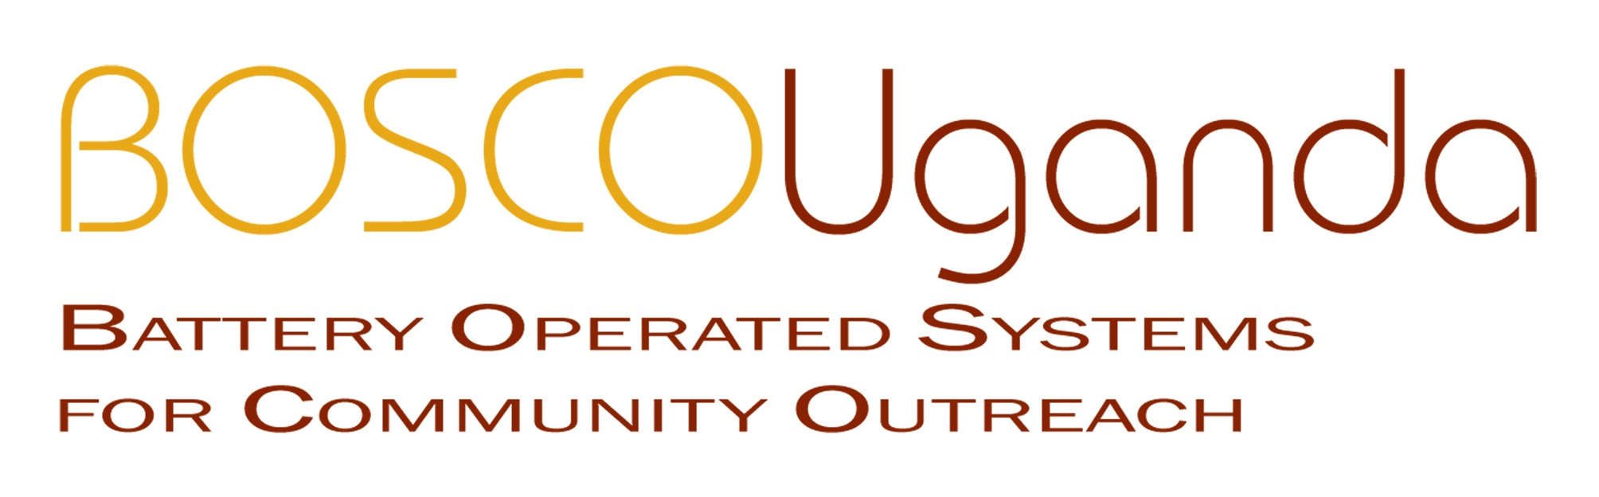

OLPCorps-University of notre Dame-Uganda-_________

A team from the University of Notre Dame will be working in northern Uganda to install XO laptops in two separate primary schools in the rural areas of Gulu and Amuru Districts—previously war-affected areas of northern Uganda. The schools planned for XO deployment include: Pagak Primary and Lacor Primary. The Notre Dame team will work directly with a local NGO called BOSCO-Uganda to deploy the XO laptops in these primary schools.
BOSCO-Uganda, the local partner, is implementing a network of low-power, solar PCs (running on Linux open-source software) that are connected to an internal high-speed network while also connected externally to a high speed ADSL Internet connection. BOSCO transmits its network connectivity signal over long-range WiFi to bring Intranet and Internet connectivity to six Internally Displaced Person (IDP) camps in northern Uganda. BOSCO has deployed a WiFi network in the aforementioned schools and would thus be a natural partner for OLPC, providing individual students with access to the Internet through XO laptops.
Traditional methods of ICT training in Ugandan schools—which emphasize a linear method for memorizing computer uses—have become obsolete. Working within BOSCO’s existing programs we will set a Web 2.0 collaboration expectation from the start, transforming the ways that students in conflict situations will contribute to their local community and to the world at large. We will empower schools by locating teachers and students who can act as local agents of change. These agents then organize themselves into collaborative user groups around XO laptops linked to the BOSCO network. After teaching students to use Web 2.0 tools and the BOSCO network Wikispace (bosco-uganda.wikispaces.com), students will begin telling their stories, articulating local needs, and designing local educational and community solutions (e.g., WikiProposal for desks). They will then begin adding remote partners in local and foreign schools as collaborators, bringing community schools together while pushing northern Uganda into the consciousness of people across the globe.
The Notre Dame team will work with BOSCO staff to deploy XO laptops. Following deployment in the primary schools, the XO team will divide their time among the schools, carrying out deployment, training, and implementation programs detailed below.
Here’s what our ND team will propose to do:
- Deploy XO laptops at above-mentioned primary schools in the month of June.
- Identify teachers and students within schools to act as agents of community change, i.e., to become XO laptop users.
- Begin intensive hands-on training and instruction for students and teachers at each site, with the goal of helping students collaborate in ways that enhance the educational and socio-cultural experience of students in northern Uganda.
- Students use Internet to learn computer literacy while enhancing their schoolwork, researching special projects in groups
- Students use BOSCO Wikispace to document their experiences, receiving feedback from peer students in the USA over BOSCO Wikispace site.
- Students use BOSCO INTRANET at each site for cultural exchange, sharing experiences in student forums and message boards.
- Students use BOSCO INTRANET for guidance and counseling, getting in touch privately with local parish priests, school administrators, and counselors to help them overcome challenges they face.

- Teachers use BOSCO Wikispace to perform their own advocacy through documentation of their challenges (e.g., http://bosco-uganda.wikispaces.com/Education+in+Pagak) while using BOSCO Internet to research more-informed and up-to-date lesson plans for their students

The impact of this program on young school children will be evaluated according to the following goals:

- Collaborative ICT literacy rates are increased
- Community activism and self-advocacy is increased through voluntary participation in designing proposals and solutions to meet educational and school needs
- Cultural traditions are documented online via Wikispace, helping restore and share a culture left stagnant by 20 years of conflict (e.g. http://bosco-uganda.wikispaces.com/John%27s+Story+2).
- A “Wiki footprint” is created, leaving a global dialogue between the people of northern Uganda and the rest of the world in the promotion of sustainable peace in the region
- Effective assessment is carried every three months (e.g. tracking users, needs-assessment, and skills gained)
All training with students at each school will take place while the schools are in session (students in school from mid-May until August; official school instruction is in English). When the Notre Dame team leaves, BOSCO will be able to carry on with continued trainings, needs assessments, and evaluation of the XO deployment, while also providing professional technical expertise using existing staff. Because BOSCO already has Intra- and Internet access points and community volunteer trainers at these three schools, sustaining the XO deployment will require minimal additional resources.

