Concept 1

Please discuss this concept and add any suggestions or thoughts you have.

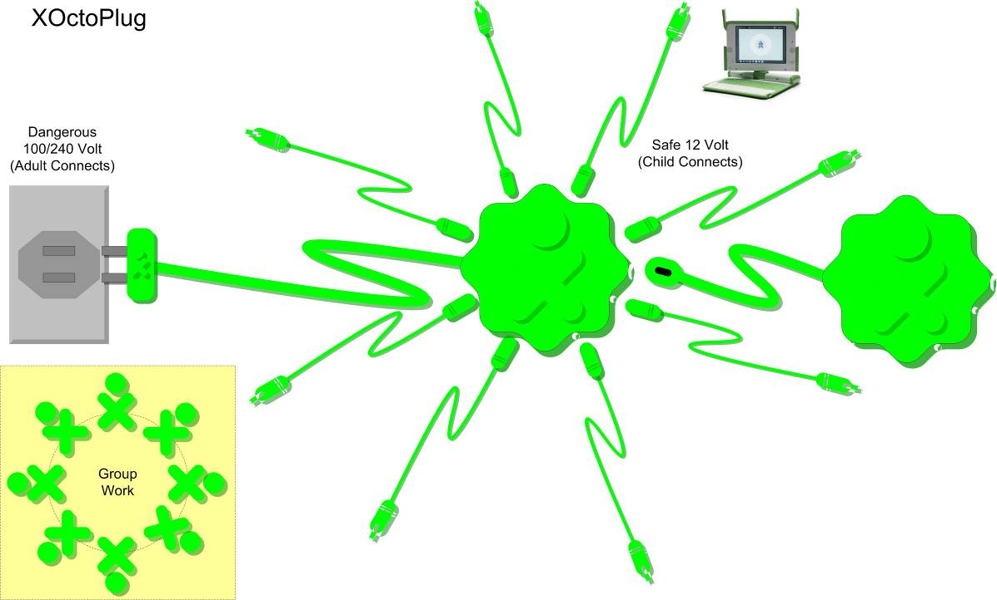

Name _____________________
Email _____________________
School ____________________

