

LESSON PLAN

ALPHABET - letter and sound

Gcompris

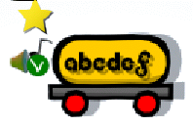

**CLICK:**

**CONTEXTUALIZATION:** Say loud or sing a song for the English alphabet. Show (or write) a letter and ask the name in English.

**HOW TO PLAY:** Listen the letter spoken and click with mouse in that letter. You can listen again clicking on the mouth icon.

**GOALS:**

- To get familiar with English alphabet (letter-name recognition, visual representation - minuscule/majuscule, sound)

|  |
| --- |
| s27.png  Click to enable the UPPERCASE |

