542 Demo Notes

From OLPCWiki
Jump to: navigation, search
This page describes the basic instructions for Build 542, the Trial 2 Build for the B4 laptops. (See Hardware release notes, Software release notes, and Library release notes for additional information).

Contents
[hide]
- 1 Important Notes
- 2 Getting Started
  - 2.1 An overview of the laptop
  - 2.2 The keyboard
  - 2.3 Opening the laptop
  - 2.4 Power on and power off
- 3 Using the laptop
  - 3.1 Home View
    - 3.1.1 XO icon
      - 3.1.1.1 Activity Circle
    - 3.1.2 Network status
    - 3.1.3 Battery status
    - 3.1.4 Frame
      - 3.1.4.1 Upper-left icons (Keys to help navigate around the laptop)
      - 3.1.4.2 Bottom icons (Keys to take you to activities)
      - 3.1.4.3 Right-side icons (your XO buddies)
      - 3.1.4.4 Left-side icons (clipboard)
  - 3.2 Neighborhood View
    - 3.2.1 Getting connected
    - 3.2.2 Joining an activity
    - 3.2.3 Adding a buddy
  - 3.3 Group View
  - 3.4 Activity Circle
  - 3.5 Activities
    - 3.5.1 Journal
    - 3.5.2 Browse
    - 3.5.3 Etoys
    - 3.5.4 TamTam
    - 3.5.5 Record
    - 3.5.6 Watch and Listen
    - 3.5.7 Write
    - 3.5.8 Calculate
    - 3.5.9 Turtle Art
    - 3.5.10 Read
    - 3.5.11 Chat
    - 3.5.12 BlockParty
    - 3.5.13 Draw
    - 3.5.14 Connect4
    - 3.5.15 News Reader
- 4 Notes
  - 4.1 Other Activities
  - 4.2 Sunlight-readable display
  - 4.3 Handheld mode (or eBook mode)
  - 4.4 Keyboard shortcuts
  - 4.5 Bugs and/or Known Issues
    - 4.5.1 Keys that do not work

[edit] Important Notes
Please note that the B4 laptops are Beta units and that the software is Alpha. We expect that the Trial-3 software will be our first Beta software release. There are bugs (please refer to the bug tracking system at http://dev.laptop.org), and not all components are operational yet.
There are still some outstanding issues with power management; battery life will improve over time.
More detail regarding the status of various software components is available on the OLPC Trial-2 Software Release Notes page in this wiki.

[edit] Getting Started

[edit] An overview of the laptop
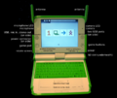
There are LED indicator lights above both the camera and the microphone to indicate if one or both are turned on.

[edit] The keyboard
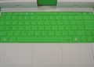
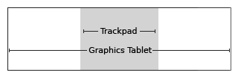
The center part of the Graphics Tablet, which is called the Trackpad (gray shaded area in picture), can be used as a pointing device. Move your finger around the Trackpad to move the cursor. The entire surface of the Graphics Tablet can be used with a stylus.

[edit] Opening the laptop
Position the handle away from you and lift both antennae ("bunny ears") up and towards you until the laptop clicks open.
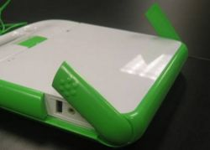
The laptop display and the keyboard are connected on a hinge. Lift the laptop display up and hold the keyboard down to open.
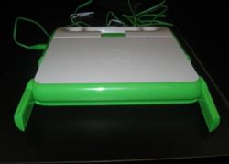
Note that the laptops in these figures are B2 units (B4 units have a dual-tone XO on the back of the machines).

[edit] Power on and power off
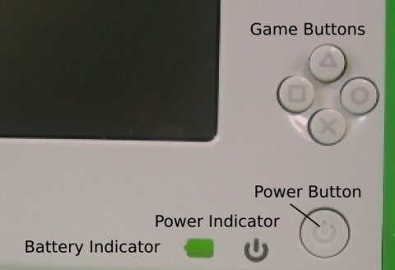
The Power Button is located in the bottom right-hand corner of the bezel surrounding the screen. Press the power button to turn the laptop on. The green power LED will come on immediately when turned on. However, it takes approximately two minutes for the laptop to boot.
Once the laptop is running, you can use the Power Button to suspend the laptop by pressing it briefly. To shutdown the laptop, you need to hold down the button for 10 seconds.

[edit] Using the laptop

[edit] Home View
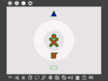
Features of the Home View include the XO icon (the XO figure in the center of the screen), the Activity Circle (which includes the Journal icon--a book and pencil), the network-status indicator (either a circle or a triangle located above the Activity Circle), the battery-status indicator (located below the Activity Circle), and the Frame;
If you leave the Home View to engage in an activity, you can return to the Home View at any time by pressing the Home Key (circle with one dot) .
or by clicking on the Home Icon (circle with one dot) on the Frame (as per above).
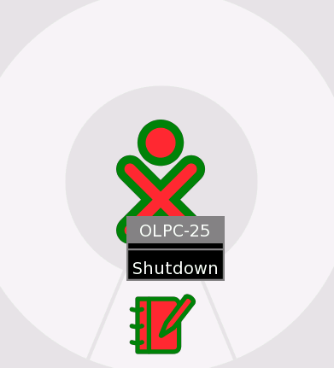

[edit] XO icon
Each laptop is assigned a color dyad that is used as an identifier throughout the interface.
A menu (hover menu) appears when you place the cursor over the XO icon in the center of the screen. As of Build 542 (software build installed on this laptop), this menu is only used to shutdown the laptop. See image above. In the future, it may be used for setting user preferences, such as colors. The XO can also be shutdown by holding the Power On/Off button down for 10 seconds.

[edit] Activity Circle
The circle around the XO icon is used to display activities that are currently running on the laptop. The Journal is always displayed at the bottom of the circle (). You can resume an activity by clicking on its iconic representation in the circle.
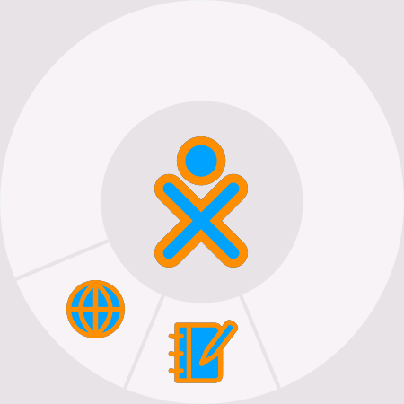

[edit] Network status
The status of the wireless network is indicated by either a circle (mesh) or triangle (access point--school server or other network) on the Home View. Details regarding connectivity are described below.
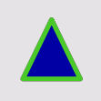

[edit] Battery status
The battery status is indicated by the battery icon. The icon fills with color from left to right to indicate the current charge. Moving the cursor over the battery icon provides a pop-up menu with more information. Please note that the battery LED, which is located in the right-bottom corner of the display screen, is illuminated when the battery is charging; it varies from yellow to green. A red light indicates that the battery is running low. 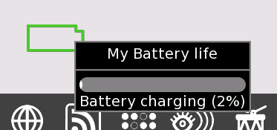

[edit] Frame
The Frame always appears on the Home View. You can toggle the Frame (to hide or show the Frame) with the Frame Key, which is located on the upper-right corner of the keyboard or by moving the cursor to any corner of the screen (aka 'Hot Corners').

[edit] Upper-left icons (Keys to help navigate around the laptop)

- Circle with eight dots: This icon takes you to the Neighborhood View; you can view network resources and other users on the mesh network;
- Circle with three dots: This icon takes you to the Group View; you can see users you have identified as friends;
- Circle with one dot: This icon takes you to the Home View;
- Circle with rectangle: This icon returns you to the Activity View; you can resume work on your current activity.

[edit] Bottom icons (Keys to take you to activities)
Different builds have different collections of activities. In Build 542, the activities available are (from left to right on the menu bar):


- BlockParty: a falling-block game;
- Draw: a drawing activity;
- Calculate: a calculator;
- Write: a word processor;
- Chat: a text chat program;
- Etoys: a programing environment;
- Browse: a web browser;
- News Reader: a RSS (Really Simple Syndication) news feed;
- Connect4: a Connect4 game (connect the dot);
- Watch and Listen: a multimedia player;
- TamTam: a music activity;
- TurtleArt: a programing environment;
- Record: a video capture activity.

[edit] Right-side icons (your XO buddies)
This menu found on the right-hand side of the Frame contains the XO icons of the people with whom you are collaborating on XO online projects.


[edit] Left-side icons (clipboard)
The menu on the left side of the Frame contains the icons for the clipboard. Most activities support drag and drop onto and off of the clipboard.

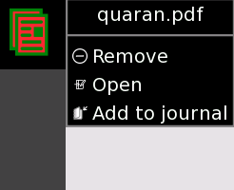

[edit] Neighborhood View
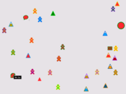
Neighborhood View
Neighborhood Icon
From the Neighborhood View (sometimes referred to as the Mesh View), you can see who is present on the network; which activities and objects are being shared; and which networks are available. You can access the Neighborhood View by pressing the Neighborhood Key (circle with eight dots -- ) or by pressing the Neighborhood Icon on the Frame.
Your XO icon appears in the center of the screen in the Neighborhood View. Moving your cursor over another XO icon will bring up a menu that provides additional details (user's name) and actions you can take (add to list of Friends). For example,
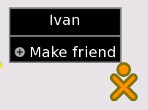.

[edit] Getting connected
Icon representations in the Neighborhood View include the circle for the mesh network and triangles for the infrastucture access points (school server or other networks). (The access points are randomly color-coded.) By default, the Network Manager (software program internal to the laptop) first tries to connect to a school server; if the connection to the school server fails, the Network Manager tries to connect with an access point (a network); if connection to the access point fails, the Network Manager connects to a mesh point on Channel 1. This searching process can take up to five minutes, since there are many channels to check and timeouts associated with each one. You can override the Network Manager by clicking on a triangle (access point). The interior of the triangle blinks while the connection is being established. The exterior of the triangle will blink when the connection is established. (If you are connecting to a WEP access point, you will be prompted for a hexadecimal key. We currently do not support WPA access point.)
More details regarding the connection:
- if you connect to an access point, your laptop becomes a mesh portal point—other XO laptops in the vicinity will be able to connect to the Internet through your laptop;
- similarly, if there is another XO laptop connected to an access point, you can connect to that laptop—and the Internet—through the mesh;
- if there are no access points available, your laptop will default to a mesh point on Channel 1, which enables your laptop to connect to other laptops;
- please be patient; it takes the Network Manager up to five minutes to progress through a number of the options until it finds a suitable connection.

[edit] Joining an activity
From the Mesh View, moving the cursor over an activity icon and pressing enter launches that activity on your laptop as a collaboration. Details of the collaboration vary from one activity to another.

[edit] Adding a buddy
Hovering over an XO icon creates a pop-up window with the name of the person associated with that icon and a menu that can be used to add this person to your Group View as a friend.

[edit] Group View
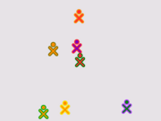
Group View
From the Group View (also known as the Friend View), you can see which friends are on the network. You can access this view by pressing the Group Key (circle with three dots -- ) or by pressing on the Group Icon on the Frame.

[edit] Activity Circle
You can initiate activities from the Home View with the Activity Circle. You can resume your current activity by pressing the Actitvity Key (circle with rectangle --) or by pressing the Activity Icon on the Frame. You can start an activity by pressing the icon for that activity from the menu bar located at the bottom of the Frame.

[edit] Activities
Switching between activities
Multiple activities can run at once. You can move between running activites by returning to the Home View (key with one dot—) and clicking on an activity found in the Activity Circle.
Exiting Activities
Every activity has an Activity tab that includes a Stop Icon . Clicking on this icon exits the activity. Alt-C works -- in most cases—as a shortcut for exiting activities. (The Keep Icon will be used for version control in the Journal.)
An instance of the activity can be renamed by typing into the text field (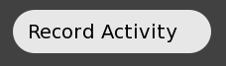) on the Activity Tab.
Many activities can be run either stand-alone or shared with other users on the mesh (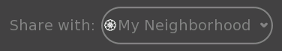).

[edit] Journal
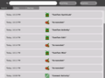  The Journal | 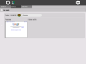  details
The Journal is accessed from the Journal Icon () at the bottom of the Activity Circle on the Home View.
The Journal automatically logs your activities on the laptop. From the Journal, you can search by keyword and sort by activity or date. Clicking on an entry brings up a detail page from which you can resume an activity (by clicking on the Activity Icon or Key) or copy its contents onto the clipboard (by pressing on the Copy Icon ).
The Journal also supports external media. When a USB key is inserted into the machine, the contents from the USB key are entered into the datastore of the laptop and become accessible through the Journal. Click on the USB icon to access the content. You can also drag and drop Journal entries on to or off of a USB key.

[edit] Browse
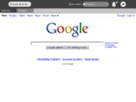
Browsing
To launch the web browser, click the Globe Icon on the Frame. The browser has two tabs: the standard Activity Tab and a Browser Tab. The Browswer Tab has an address field, forward and backward history buttons, as well as a reload button.

[edit] Etoys
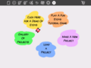  Etoys start screen | 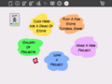  The Etoys badge is used for sharing.
From the Frame, press the shooting-star icon ; the Etoys activity will load and present a launch screen.
An Etoys tutorial can be found here.

[edit] TamTam
From the Home View Frame, click on the drum icon—.
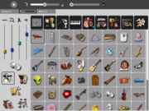
TamTamJam
Use the keyboard to play sounds at different pitches.
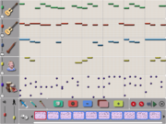
TamTamEdit
Use TamTam Edit to compose music.
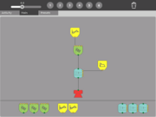
TamTam Synth Lab
Use TamTam Synth Lab to create new instruments.

[edit] Record
The video and still image record activity is launched by pressing on the Camera (Eye) Icon— in the Frame. If you share the camera activity, then a Camera Icon appears in the Neighborhood View. Other users can launch the Record Activity from the Neighborhood View () and share pictures.
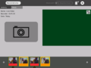  Record sharing | 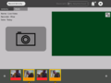  Record sharing

[edit] Watch and Listen
Watch and Listen is based on the Helix multimedia player. It supports a variety of audio and video formats. Launch the Watch and Listen progrm by clicking on the icon in the Frame.
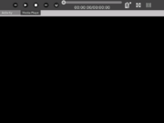
Multimedia

[edit] Write
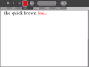  Write | 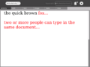  sharing
Write, based on the Abiword word processor, is a basic word processor. To launch Write, press the Write icon in the Frame. When shared, multiple people can simultaneously edit the same document (i.e., group editing). To launch Write as a group activity, press the Write Icon from the Neighborhood View (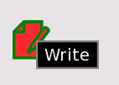).

[edit] Calculate
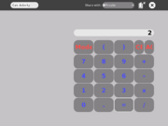
Calculate
Calculator activity provides classic calculator functions such as add, subtract, divide and multiply, as well as scientific functions such as cos, sin, exp, etc. To launch the Calculator application press the calculator icon from the Frame.

[edit] Turtle Art
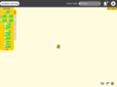 | 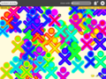
TurtleArt is a programming environment that uses tiles. To launch the Turtle Art application press the icon on the menu bar in the Frame.

[edit] Read
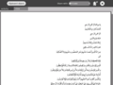 | 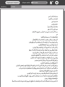
The Read (PDF) Activity allows you to share books on the mesh (in the Neighborhood View) .

[edit] Chat
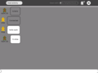 | 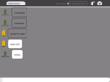
To start a chat, open the Chat Activity by clicking on the balloon icon— in the Frame. A Chat Icon will appear in the Neighborhood View on each laptop in the mesh: other users can join the chat by clicking on this icon (). Enter text at the bottom of the screen on one XO, and the text will appear on the screen on other XOs engaged in the chat.

[edit] BlockParty
A Tetris-like game. Launch Block Party by pressing the icon on the meunu bar in the Frame.

[edit] Draw
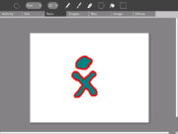
Draw
This is an activity to make drawings and paintings. Launch Draw by pressing the Draw icon on the menu bar in the Frame.

[edit] Connect4
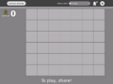 | 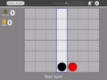 | 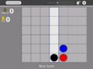
Connect4 is a two-player game. Player One launches the game from the menu bar on the Frame . Player Two joins the game by selecting the Connect4 icon in the Neighborhood View (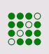).

[edit] News Reader
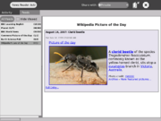
News Feed
A Really Simple Syndication (RSS) feed of current news. To launch the News Reader, press the News Reader icon on the menu bar on the Frame.

[edit] Notes

[edit] Other Activities
There are many more Activities that can be loaded onto the laptop. Automatic installation is working in recent builds (547+) but not yet in Build 542.
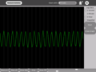  Measure | 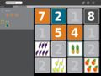  Memonumbers | 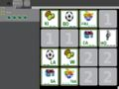  Memoletters

[edit] Sunlight-readable display
The XO's unique display works both indoors and in direct sunlight. The display works in the following ways:
- A color image is generated from the backlight passing through color filters in the display.
- A high-resolution grayscale (black and white) image is generated from ambient light reflecting off of mirrors in the display.
- When the backlight is on and there is a source of ambient light—the sun, a room light, etc.—you see the combination of two displays.
- You can save power (and thus extend battery life) by turning the backlight off. The display remains visible, but there is no color.
- If the ambient light is too intense, the color is washed out; typically you would turn off the backlight in sunlight.
On the top row of the keyboard, there are three long buttons. The long button on the far right controls the lighting and sound on the display.
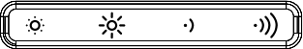
This long button contains four keys. The left two keys control the lighting.
- The small sun key on the left dims the backlight when pressed; repeated presses on this key puts the display into black and white mode.
- The large sun key, the second key from the left, increases the brightness of the backlight and enables color mode when pressed repeatedly.
The two keys on the right of the long button are used to decrease and increase speaker volume.

[edit] Handheld mode (or eBook mode)
When in the eBook mode, the keyboard and touchpad are covered. Only the game controller buttons, which can be used for scrolling, the camera, and the microphone, work.
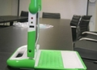  Bring the display up to a 90-degree angle (and put the antennae down). | 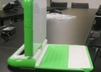  Rotate the display 180 degrees until it is facing backwards. | 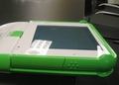  Lay the display down onto the keyboard. | 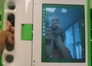  Enjoy!

[edit] Keyboard shortcuts
Ctrl-C – copy
Ctrl-V – paste
Ctrl-X – cut
Alt-C – quit
Ctrl-Alt-Erase – restart Sugar (and X Windows)
Alt-= – toggle on/off developer console
Ctrl-Alt-F1 – console (1)
Ctrl-Alt-F2 – console (2)
Ctrl-Alt-F3 – X Windows
Alt-1 – save snapshot of screen into the Journal
(F1 is the same as the Neighborhood View Key; F2 is the same as the Friends View Key; F3 is the same as the Home View Key.)

[edit] Bugs and/or Known Issues

[edit] Keys that do not work
— Journal search key
— Bulletin-board key
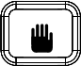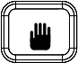— Grab keys (on either side of the space bar)
Retrieved from "http://wiki.laptop.org/go/542_Demo_Notes"

