LESSON PLAN
NUMERATION – numeric order
Gcompris

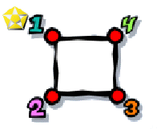
CLICK:

GOALS:
- To get familiar with the numeric order. First level is until 5. Last level is until 50.

CONTEXTUALIZATION: Write the numeric sequence until 50.

HOW TO PLAY: Draw the picture by clicking on each number in the right order: 1, 2, 3 …

