
XO Kazubwenge

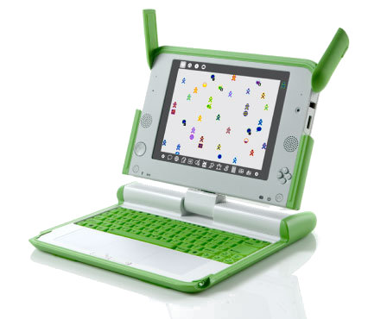
XO Time – week 19

Hello my Rwandese friends!

Since you did really well in Scratch, this week we are going to start a new kind of challenge using Turtle Art !


You can find Turtle Art in your XO laptop clicking on this Turtle
To draw in Turtle Art, you just drag and drop the blocks and double-click over the blocks. If you connect more than 1 block, we call it Script.

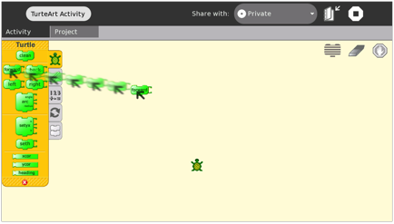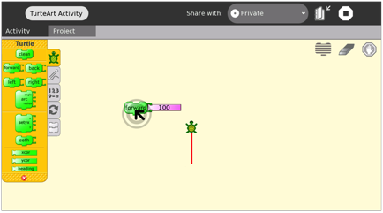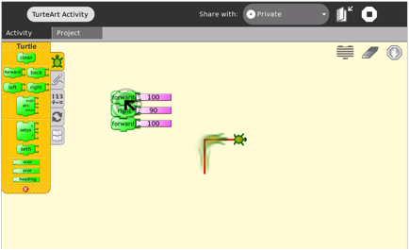
BLOCK
SCRIPT

To erase the drawn (marks made by the turtle), click on the eraser .

This week my challenge for you is: To Create a Script (many blocks connected) to draw the shapes below: 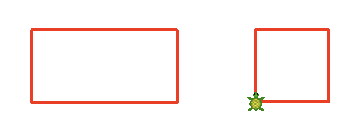

My friends from OLPC are on vacation like you. So, instead of going to Bourbon Café to have help, you can invite your friends and try solve it together in a place that is good for you.
Each week I will send a new design and you need figure out how to draw it in your XO laptop.

Click here and put a name for the cat

Send your questions to: xo@laptop.org

