Project Initiation Document (concept)
Introduction of XO laptops for (visual impaired) school students in Pskov and Nizhny Novgorod, Russia

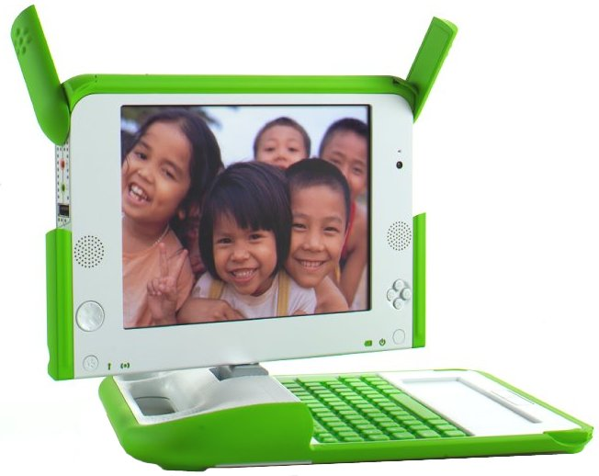

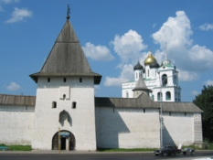
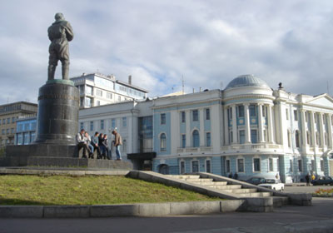

Pskov
Nizhny Novgorod

Version 1.22 (concept)
March 16. 2008
Harrie Vollaard
Contents

Chapter 1 Document history 4
Document history: 4
Distribution list: 4
Chapter 2 Vision 5
Chapter 3 Why OLPC 5
Chapter 4 Strategic implementation plan Russia 5
Stage 1: Testing XO laptop 6
Stage 2: Pilot OLPC 6
Stage 3: Roll out of OLPC 6
Chapter 5 Introduction and background stage 2; pilot OLPC 7
Chapter 6 Project objectives 8
Chapter 7 Localization 8
Chapter 8 Assumptions and constraints 9
Chapter 9 Project deliverables 9
XO and infra 9
Educational level 9
PR 9
Input implementation phase (stage 3) 9
Chapter 10 Description of work 10
Tasks and timelines (February 2008 – October 2008) 10
Gantt Chart 10
Field indicators 11
XO and infra 11
Students 11
Teachers 11
Educational platform 11
Risk management 12
Capacity building 12
Chapter 11 Project organization 13
Project members 13
Chapter 12 Project budget 15

Document history

Document history:

Version | Date | Author
Version 0.6 | February 9. 2008 | Harrie Vollaard
Version 0.9 | February 15. 2008 | Comments of Olga Ursova, Boris Yarmakhov, Gertie Clabbers
Version 0.91 | February 17. 2008 | Harrie Vollaard
Version 1.21 | March 16. 2008 | Boris Yarmakhov, Harrie Vollaard

Distribution list:

Version | Date | Author
Version 0.6 | February 9. 2008 | OLPC Russia, Foundation
Version 0.9 | February 15. 2008 | OLPC Russia, City Administration, Centre of Distance Learning, Nizhny Novgorod Pedagogical University
Version 0.91 | February 17. 2008 | OLPC The Netherlands, OLPC Global, OLPC Russia, City Administration Pskov, Centre of Distance Learning, Nizhny Novgorod Pedagogical University
Version 1.21 | March 16. 2008 | OLPC The Netherlands, OLPC Global, OLPC Russia, City Administration Pskov, Centre of Distance Learning, Nizhny Novgorod Pedagogical University

Vision
The need for a broad scale OLPC implementation in Russia is driven by the general situation with computer and IT equipment in Russian schools. According to the World Bank data the ratio of students to a computer in most Russian schools is 30:1. This makes acquiring XXI century skills problematic for the most part of the student population.
Currently Russia has about 16 million school students. For most of them access to IT and connectivity in particular will become a crucial point in their future career building. As never Russia needs well-educated, creative citizens. The new Russian administration claims to understand that and to promote change and innovations in social sphere, education in particular.
Using OLPC XO in teaching disabled (visually impaired, in particular) children might be a very effective use of this technology as well as a solution of one of the gravest problems of Russian education. Current Russian educational structure does not see a place for such kids in a regular public school where they could learn together with their peers and take the most from day-to-day communication with them. The current practice cuts these kids off from the rest of the student population and puts them into boarding schools for visually impaired where they can communicate only with other visually impaired children.
OLPC solutions might be very helpful as they have a number of activities that could be used by VIC (Speak as an example). Providing such children with XO laptops on a day and night basis (model of ubiquitous computing) will solve the issue of their lack of communication with peers.

Why OLPC
Russian educational community has both interest and potential for implementing the model of ubiquitous computing in elementary and middle schools.
A Russian aluminum tycoon Oleg Deripaska (through its foundation Free Deed) who is buying 1.000.000 UMPC’s for Russian schools. At the moment the foundation is focused on ASUS EEE, but they are open for discussions. A successful OLPC pilot may become a very serious argument both for them and for the government.
As a solution we see large scale implementation of OLPC technologies into Russian secondary education system. OLPC is our first choice as it:

- Allows to supply hundreds of thousands of students with affordable equipment and free software.
- Is based on revolutionary constructionist educational technologies.
- Helps to establish high connectivity learning environment.

Strategic implementation plan Russia
We see OLPC implementation in Russia as a sequence of the following stages:

Stage 1: Testing XO laptop
Testing of the XO laptop, its application and activities. Building the project team that will disseminate results of the pilot project.
Currently OLPC Russia community is working on localization of the XO software and creates publicity for the project at various conferences (Stage 1; Testing XO laptop).

Stage 2: Pilot OLPC
At the pilot stage of the OLPC project working models of teaching with OLPC methods will be created. Project team members will test XOs teaching elementary school students. Teacher training solutions will be modeled.
The pilot project in Nizhny Novgorod and Pskov (Russia) is planned as the second step in a broad scale roll out process of implementation of OLPC educational methods into Russian schools. A successful pilot will help to propagate OLPC as an alternative to out dated instructionist approaches and create a model, that will be used in educational institutions nationwide.

Stage 3: Roll out of OLPC
Results of the pilot project will be disseminated at a large scale.

The project initiation document will focus on stage 2; pilot OLPC.

Introduction and background stage 2; pilot OLPC
The mission of the One Laptop per Child association is to develop a low-cost laptop—the "$100 Laptop"—to revolutionize the way the children of the world are educated. The goal is to provide children around the world with new opportunities to explore, experiment, and express themselves (http://wiki.laptop.org/go/The_OLPC_Wiki). The laptop (XO) is a very cheap and sustainable device especially developed to work wherever in the world. Today several projects around the world are being deployed. Also Russia is one of the countries that have expressed an interest at the Ministry of Education level or higher. The grass root organization OLPC Russia is almost done with the localization of the XO software. There will be an opportunity to introduce the XO in Russia during the trip of Harrie Vollaard and Gertie Clabbers through Russia because the Foundation Meters Maken voor Millennium (Making Miles for Millennium) is able to finance the needed XO’s. The trip is focused on how to develop and stimulate OLPC-initiatives. They are doing that by generating publicity and raising funds.
The city Pskov (Russia) has a town twinning with Nijmegen (The Netherlands) which makes it easier to introduce the first XO’s, because there are already relationships with all the involved parties. The partnering organization in Pskov is The Center for Distance Learning Education (contact person - Olga Ursova). The city Nizhny Novgorod (Russia) is the other city to introduce the XO’s at a school for visual impaired children and at an ecological summer camp. The partnering organization in Nizhny Novgorod is the Nizhny Novgorod State University (contact person - Boris Yarmakhov). At the moment OLPC Russia volunteers community consists of 10 people - educators, translators, software developers, students. The reasons why a summer camp was chosen as a first event to introduce OLPC into Russian educational practice are the following:
The summer camp environment provides plenty of opportunities for children to benefit such outstanding features of OLPC as connectivity, ruggedness and sun light friendly display viewing mode. While on field trips children will be using mesh network and reading from the laptop screen in the sun light.
While on field trips children will create and share collections of digital objects (flora and fauna samples) and write about their experience in a collective diary/blog.
Application of Scratch - a multimedia programming language recently optimized for XO will be tested as an environment for extracurricular activities.
Children and teachers involved in the summer school activities will not feel any stress connected with the requirements of the school program which will allow to implement the model of ubiquitous computing at its best.
This is the best way to determine the added value of the XO in a field experiment.
The unique selling points of the projects are:
- First introduction of XO’s in Russia
- The special way of introduction generates publicity more easy
- Accessibility of the XO for visual impaired children

Project objectives
The main objective of the project is to determine how the One Laptop Per Child initiative can be successfully introduced in Russia.
To achieve this objective two pilot initiatives need to be done:
- Introduction in Pskov
Introduction of 15 XO’x in Pskov at different schools and to the different stakeholders within Pskov.

- Introduction in Nizhny Novgorod

  - Introduction of 35 XO’s at the Nizhny Novgorod Pedagogical University to the Nizhny Novgorod educators (schools also for visual impaired children and colleges). June, 6-10 (TBA) together with

  - Introduction of the XO to students at an ecological summer camp in Nizhny Novgorod.

Localization
The two pilot locations are in Pskov and Nizhny Novgorod. Pskov is near St. Petersburg.
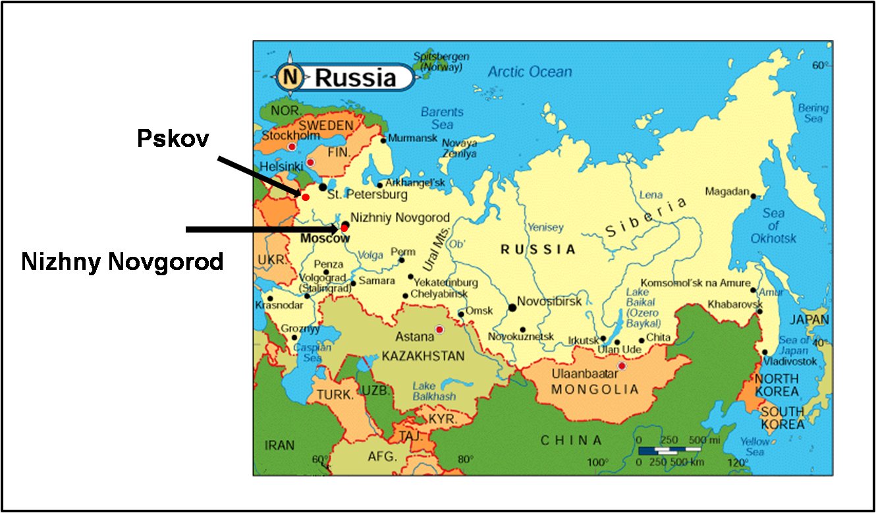

Assumptions and constraints

- Localization of the XO is not a part of the project. It is a continuing process but will be on a sufficient level at the time of introduction.

Project deliverables

XO and infra

- 15 localized XO’s in Pskov for The Center for Distance Learning Education and City Administration Pskov.
- 35 localized XO’s at the school for visual impaired children and at an ecological camp Nizhny Novgorod.
- A working environment of ubiquitous computing.
- Text2Speech software for visual impaired children

Educational level

- To enhance OLPC Russia educational community with hands on experience.

PR

- Creating publicity for OLPC as an innovative educational technology.
- To propel localization of XO software into Russian.

Input implementation phase (stage 3)

- Stakeholder analysis; The analysis gives the insight what the success criteria will be to introduce XO’s at a larger scale in Pskov and Russia.
- Evaluation report Nizhny Novgorod on the added value of the XO for students.
- Evaluation report Pskov/Nizhny Novgorod with a go/no go for larger scale deployment

Description of work

Tasks and timelines (February 2008 – October 2008)

- Generate funds for the introduction of the XO’s in Pskov and Nizhny Novgorod, Foundation, OLPC Russia
- Achieve commitment from local government Nijmegen, Russian authorities and Stichting Stedenband Nijmegen – Pskov for the project, Foundation
- Achieve commitment from local government Pskov for the project, The Center for Distance Learning Education
- XO application and distribution, Foundation and OLPC Russia
- Text2Speech software development, OLPC, Foundation
- Generate publicity in The Netherlands, Foundation
- Generate publicity in Russia, OLPC Russia
- Determine schools, OLPC Russia, City Administration Pskov and The Center for Distance Learning Education
- Determine how to introduce the sample XO laptops at the schools and teachers, City Administration Pskov and The Center for Distance Learning Education
- Determine agenda and program for stay at Pskov, May 21. – May 24.
- Meeting with stakeholders (OLPC Russia, IT, Foreign Department, City Administration) in Pskov, May 22.
- Orientation in Pskov on educational level with the person in charge for education, May 21.
- School visits and introduction of some sample XO laptops on different schools, May 22. – May 23.
- Generate publicity local and internationally about the visit, Foundation
- Presentation in Nizhny Novgorod, June 6 -10., OLPC Russia, Nizhny Novgorod Pedagogical University
- Summer camp at Nizhny Novgorod, July, OLPC Russia, Nizhny Novgorod Pedagogical University

Gantt Chart

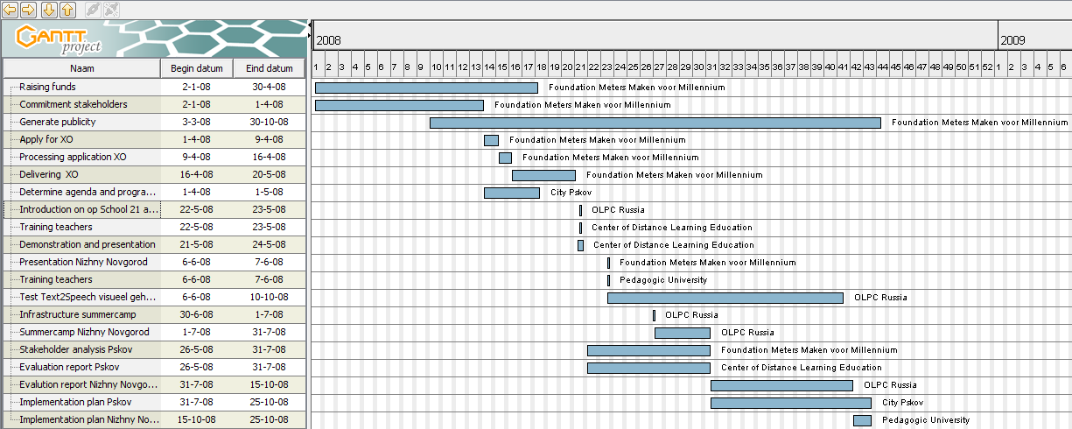

Field indicators

XO and infra
- Test of the usability of Text2Speech software for visual impaired children.
- 35 XO laptops will be used simultaneously to test mesh network building for various connectivity educational solutions.
- A field science laboratory and Measure activity will be tested (100 water and air samples will be taken).
- 10 localized Russian applications will be tested.

Students
- Added value of the XO for student at the school for visual impaired children and the ecological camp.
- 50 students will learn how to use XOs and Sugar interface.

Teachers
- Training for teachers.
- Teachers and students participating in the summer camp will reflect on their experience in a collective blog.

Educational platform
- A repository of XO based Scratch scripts will be built.
- A collection of Nizhny Novgorod flora and fauna digital objects will be created.
- A OLPC_Russia wiki-wiki repository with 100 personal and digital object pages will be created.

Risk management

- Cooperation of government and schools (OLPC Foundation, Letter of support)
- XO delivered on time (OLPC Foundation)
- XO delivered in Russia (OLPC Foundation)

Capacity building

On several levels will be worked on capacity building:
- On central level: In April will Matt Keller; director Europe, Middle East and Africa of OLPC meet with Ella Pamfilova; advisor of president Medvedev and will have talks with the ministries of Foreign Affairs and Education about OLPC and Russia. To prepare the talks Matt Keller will meet the Foundation Meters Maken voor Millennium on March 19.
- On local level: Via the foundation Twinning City Nijmegen – Pskov and the city administration of Nijmegen the relationship with the city administration is very well. Tatjana Rumjantseva of the City Administration of Pskov will meet the foundation at their visit in Pskov and will bring OLPC Russia in contact with the responsible person in charge of Education.
- On school level: In cooperation with the Center of Distance Learning Education and the Pedagogic University of Nizhny Novgorod the teacher will be trained.
- On OPLC Russia level: By means of demonstrations and presentations the possibilities of the laptop in education will be shown.

Project organization

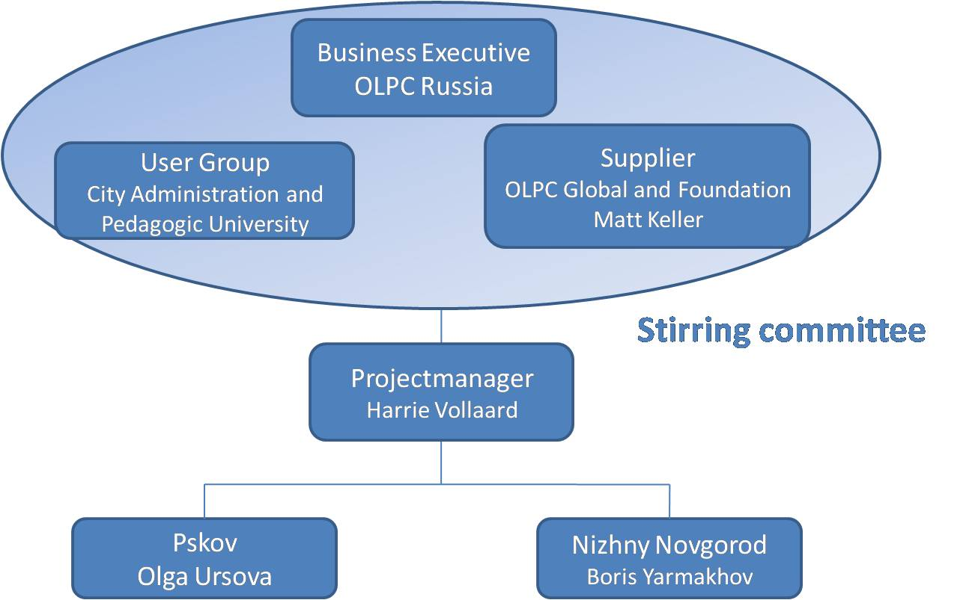
The general project organization of stage 2; introduction of XO laptop in Pskov and Nizhny Novgorod is:

Project members
- OLPC Global (Matt Keller)
- OLPC Russia (Boris Yarmakhov, Olga Ursova, Evgeny Patarakin)
- Center of Distance Learning Education Pskov (Olga Ursova)
- Nizhny Novgorod Pedagogical University (Boris Yarmakhov)
- City Administration Pskov (Tatjana Rumjantseva)
- Foundation Meters Maken voor Millennium; Making Miles for Millennium (Harrie Vollaard, Gertie Clabbers)
- Review group City Twinning Nijmegen – Pskov (Jan Roelofs)
- Schools
- Primary school Klein Heyendaal, Nijmegen (Lya van de Hoogen)
- School 21, Pskov (school twinning with Dutch school)
- Palkinskaya school and Seredkinskaya school

For the local pilots the project organization together with the main responsibilities is for:

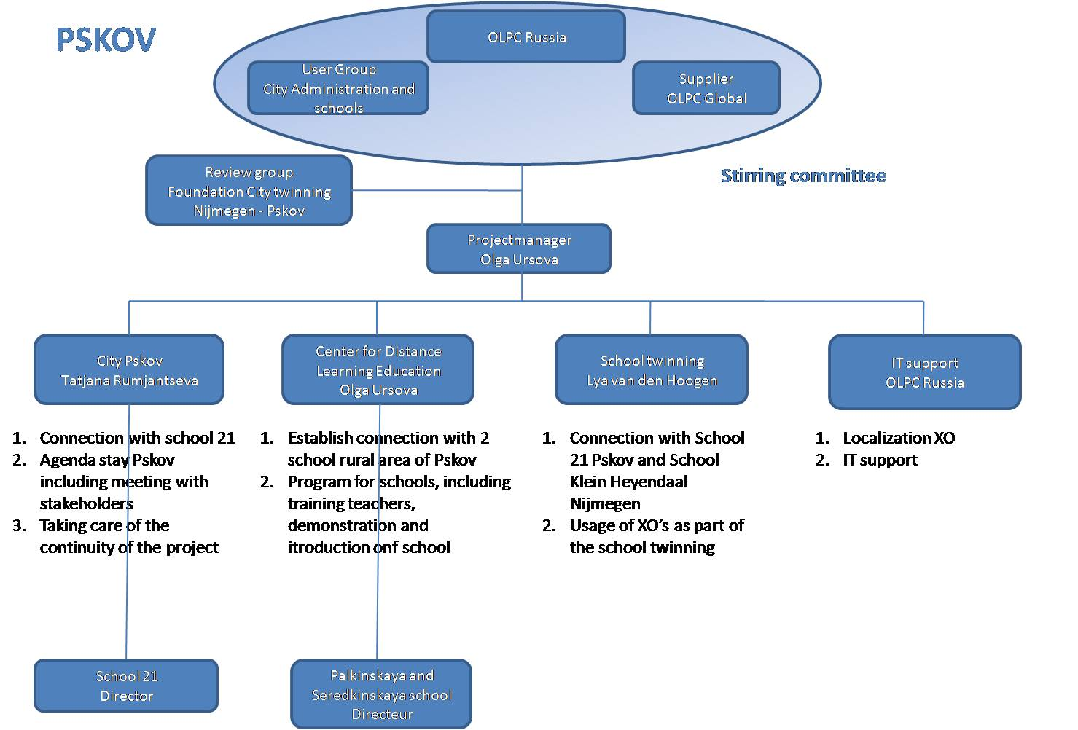
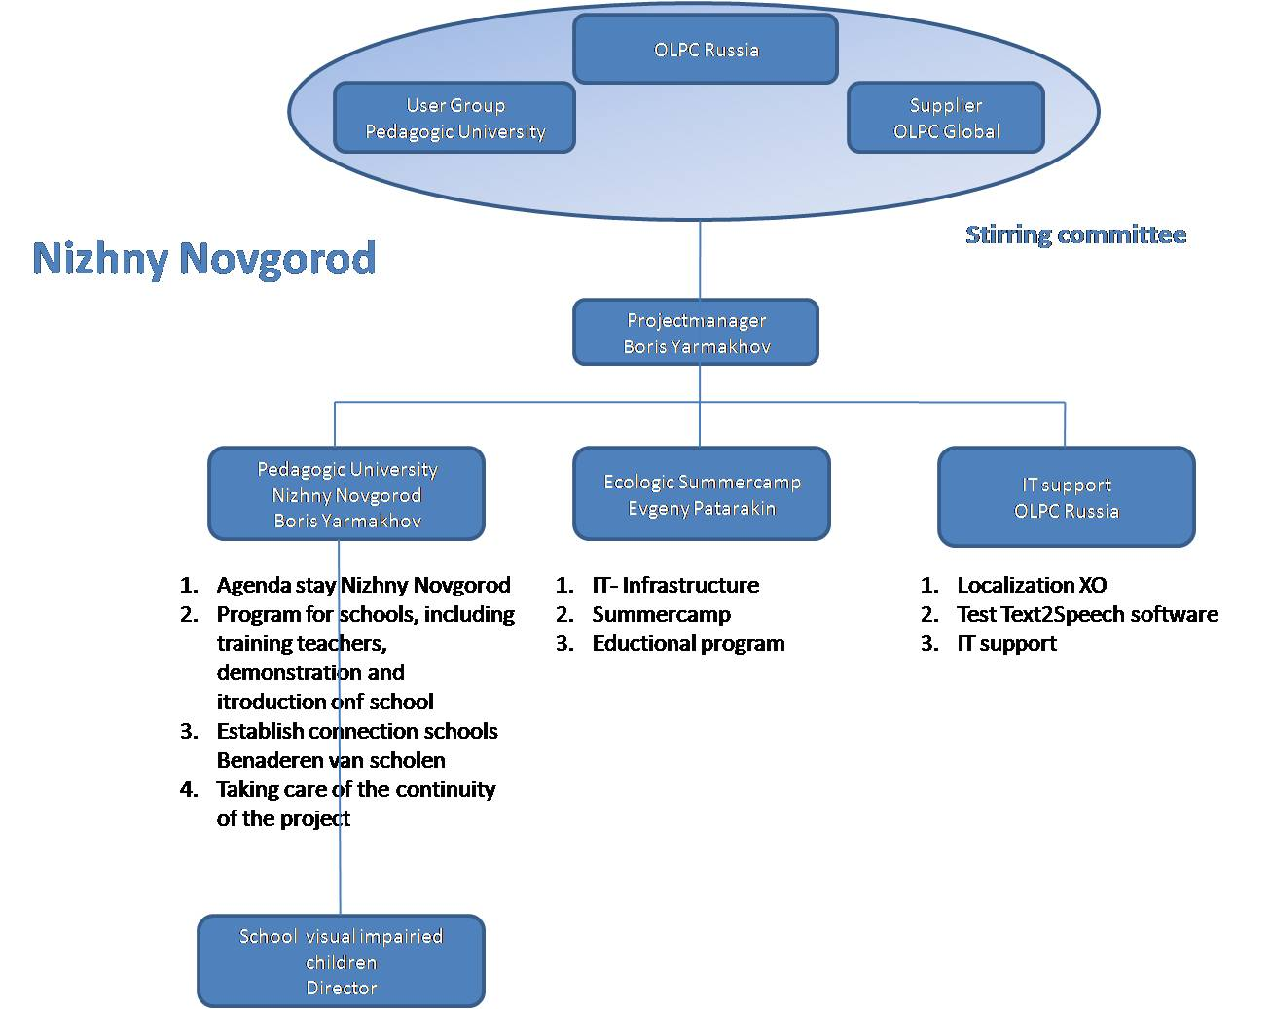

Project budget

Activities | Costs (EURO) | Costs (Rubles)
Project management 400 hr | 0 | 0
Hardware costs
50 XO Pskov and Nizhny Novgorod ($ 200)
IT Infrastructure
- USB GPRS Modem Novatel Ovation MC950D ($450)
- Router Billion BiPAC 7300GX 3G/ADSL2 ($250)
- 3 x Notepower Solar Laptop Computer Charger ($440)
- USB GPS Navigator GLOBALSAT BU353 SIRFSTAR III USB GPS RECEIVER ($130)
- Nova 5000 portable digital laboratory ($280)
- LEGO® MINDSTORMS® NXT set ($1000)
Software
Development software application for Visual Impaired Children
Travel costs related to XO-project
Transport costs of XO
Promotional costs
Total
Appendix

Involved OLPC members:

- Matt Keller (OLPC Global, director EMEA)
- Boris Yarmakhov (OLPC Russia. Nizhny Novgorod) is an educator with 15 years of experience of teaching at secondary school and University levels. Experienced user of PC systems and peripherals, digital photography, sound recording. Software skills include the Internet applications, distance learning systems, educational software.
- Yevgeny Patarakin (Scratch Russia) is an IT and education expert with 20+ years of experience. Proficient with Scratch, Logo, Moodle, wiki-wiki systems. Experienced user of PC systems and peripherals, GPS navigation.
- Olga Ursova (CDE, Pskov) is an educational specialist in the area of distance learning systems. Experienced with PC systems, office applications, and various educational software.
- Harrie Vollaard (OLPC The Netherlands, Foundation Making Miles for Millennium) is innovation director with 10 years experience with new technology (biometrics, RFID, NFC, RIA, widgets, video communication, accessibility tools, Linux, GRID technology, iTV, virtual worlds etc.) in a major bank in the Netherlands. Capabilities: Innovation management and project management.
- Gertie Clabbers (OLPC The Netherlands, Foundation Making Miles for Millennium) is occupational therapist. She set up activities with people with a psychiatric background and support and stimulates them. Experience with PC and office applications.

